COMPUTER CENTRE

RESERVATION SYSTEM

BY

CHEONG JI XIANG

SESSION 2022/2023

FACULTY OF INFORMATION SCIENCE & TECHNOLOGY

MULTIMEDIA UNIVERSITY

JULY 2023

COMPUTER CENTRE

RESERVATION SYSTEM

BY

CHEONG JI XIANG

SESSION 2022/2023

THE PROJECT REPORT IS PREPARED FOR

FACULTY OF INFORMATION SCIENCE & TECHNOLOGY

MULTIMEDIA UNIVERSITY

IN PARTIAL FULFILLMENT

FOR

BACHELOR OF INFORMATION TECHNOLOGY

B.I.T. (HONS) SECURITY TECHNOLOGY

FACULTY OF INFORMATION SCIENCE & TECHNOLOGY

MULTIMEDIA UNIVERSITY

JULY 2023

© 2018 Universiti Telekom Sdn. Bhd. ALL RIGHTS RESERVED

Copyright of this report belongs to Universiti Telekom Sdn. Bhd as

qualified by Regulation 7.2 (c) of the Multimedia University

Intellectual Property and Commercialization policy. No part of this

publication may be reproduced, stored in or introduced into a retrieval

system, or transmitted in any form or by any means (electronic,

mechanical, photocopying, recording, or otherwise), or for any

purpose, without the express written permission of Universiti

Telekom Sdn. Bhd. Due acknowledgement shall always be made of

the use of any material contained in, or derived from, this report.

**DECLARATION**

I hereby declare that the work have been done by myself and no portion of the work

contained in this thesis has been submitted in support of any application for any other

degree or qualification of this or any other university or institute of learning.



____________________

CHEONG JI XIANG

Faculty of Information Science & Technology

Multimedia University

Date: 5/1/2023

**Acknowledgment**

I would like to thank everyone who had help me and support me to finished this final year project. I would like to express my special thanks to gratitude to my supervisor Dr. Khoh Wee How for his guidance and support throughout this project. My report could not be completed now without the help of Dr. Khoh.

Next, I also appreciate my family encouraging me and my friend who giving me support during the process of this project. Their encourangemnet and support are very important elements that helped me complete this project.

Last but not least, my sincere thanks to everyone who contributed, directly or indirectly, without whom I would never have completed this final year project.

**ABSTACT**

A reservation system are become more and more common, a reservation system can help a organization manage their customer easily. Traditional way to manage reservation are using handwriting on a paper to record, but this way is time-consuming, and the documentation will become more larger to maintain, this may also affect the feeling for the customer who need to wait for a long time. Hence, this project is to implement a computer centre reservation system to help the customer can check and book for a reservation easily, also support the employee to have a better management of customer and reservation, no need to rely on manual handwritting record. The result of implement a reservation system not only can improve the management of customer and reservation, also improve the comfortable of customer to book a reservation, the communication between customer and employee may also improve by reservation system.

TABLE OF CONTENT

**DECLARATION III**

**ACKNOWLEDGEMENT IV**

**ABSTRACT V**

**TABLE OF CONTENT. VI**

**LIST OF TABLES VIII**

**LIST OF FIGURES IX**

**LIST OF ABBREVIATIONS/SYMBOLS X**

**LIST OF APPENDICES XI**

**CHAPTER 1 INTRODUCTION 1**

**1.1 Overview 1**

**1.2 Problem Statement 2**

**1.3 Project Objective 3**

**1.4 Project Scope 4**

**1.5 Gantt Chart 5**

**CHAPTER 2 LITERATURE REVIEW 6**

**2.1 Introduction 6**

**2.2 SENET 7**

**2.3 Antamedia 14**

**2.4 Pancafe Pro 20**

**2.5 Comparison among all the researched system 23**

**CHAPTER 3 METHODOLOGY 25**

**3.1 Software development life cycle 25**

**3.2 Comparison of different SDLC 26**

**3.2.1  Traditional Waterfall SDLC 26**

**3.2.2 Agile Methodologies and eXtreme Programming 27**

**3.2.3 Conclusion 27**

**3.3 Development hardware & software requirement 28**

**3.4 System development language 29**

**CHAPTER 4 SYSTEM DESIGN 31**

**4.1 SYSTEM FUNCTION 31**

**4.2 Context Diagram 33**

**4.3 Data flow diagram 34**

**4.4 Entity Relationship diagram 36**

**4.5 Use Case diagram 37**

**4.6 Database Tables 38**

**CHAPTER 5 SYSTEM IMPLEMENTATION 40**

**CHAPTER 6 TESTING 50**

**CHAPTER 7 CONCLUSION 60**

**7.1 Conclusion 60**

**REFERENCES 61**

**APPENDICES 62**

**LIST OF TABLE**

**Table 2.4.1 feature comparison among three reservation system 24**

**Table 3.3.1 Minimum System Requirement 28**

**Table 3.3.2 Software requirement 28**

**Table 4.6.1 Admin Table 28**

**Table 4.6.2 Computers Table 28**

**Table 4.6.3 Users Table 28**

**Table 4.6.4 Stock Table 28**

**Table 4.6.5 Orderdata Table 28**

**LIST OF FIGURES**

**LIST OF ABBREVIATIONS/SYMBOLS**

**FYP Final Year Project**

**SDLC Software Developement Life Cycle**

**CRS Computer centre Reservation System**

# INTRODUCTION

### Overview

In this era, computers have been popularized in many families, it makes people's life more convenient, they can use computers to look up any information on the Internet, chat or video call with family and friends, buy goods from online markets, etc., but not everyone has computers, and not everyone has a very good computer. Even people with good computers don't necessarily have fast internet. Therefore, many people will choose to go to the computer centre to borrow computers for office work, entertainment, and watching movies.

In the computer centre, their main job is to rent computers, so all the specifications of their computers are standard, and the network will be fast and stable. They will have earphone and microphone, some computers in the centre will install games for easy play and relaxation, Microsoft office for office workers to work, and even some computers will install development tools specifically for developers to use. If there is no application you need, the network there can also allow you to download and use immediately.

In Japan, have many 24/7 computer centre that have separate room for each person. The room not only have computer, chair, but also bed for people to rest, the computer centre even have bathing facilities. If you work too late or if you need to travel locally it is a good place to stay for days. Japanese government study that over 5,400 people are spending at least half of their week staying in the centre(Net_cafe_refugee. (2022, November 8). In Wikipedia.).

This project is to develop an online computer centre reservation system. Instead of walking indoor to the computer centre and ask for a reservation, it should have a way to check and book for a seat in the computer centre anywhere to avoid come for nothing when there are no seat. For the people who having a plan can also prevent their schedules from being disrupted.

### Problem Statement

For many computer centre that are not using any reservation system having many problem when the number of people booking increase. Customer cannot get a satisfy seats all the time, a group of friend come to relax may need to sit separately. Customer have no way to check if the computer centre having available seats or not, when the computer centre is full, new customer may come for nothing. Customer who have registered an account in the computer centre cannot view all the records they have made with computer centre.

There is a lot of manual work and preparation need to be done if do not have a reservation system to support the employee. When a new customer visit the centre, new user account may need to register an account, employee need to record down all the user information manually, then only help them to create their account. When there is a number of customer who have registered an account here, it will be time-consuming if the employee need to check line by line. Employee also need to keep tracking the time, when a customer come to bill employee need to record down all the record and receipt to the user account. Manually record may cause time consuming and increase the possibility of causing error

# All the record have different function, different person have different way to record, they also have different hand writing, these make the documentation are hard to maintain. All the file are also not secure if all the reports and information are record manually.

### Project Objectives

The main objective of this project are:

* To develop a computer centre reservation system that solve uncomfortable problem employees and customer. Customers can register an account themself anywhere with the website, they can view all reservation schedules to see when seats are available. Employees can use the schedule to have a better record of the reservation and have a better control to the user account, this may help strengthen the management of the computer centre.
* To develop a computer centre reservation system that can have the function to support the employee to record and manage, for example: billing, reservation record, calculation of each reservation, etc.
* To develop a computer centre reservation system that can protect the important information like account password of the customer.

### Project Scope

The project scope of this reservation system is for the convenience of customers and employees.

### Employees can manage all the information in the system, they can check the record of the user account, check the reservation is correct or not, also have the permission to check contact information of the customer to have further contact. All the record will also available in the system for further management. Employees have the admin account which have the highest permission beside developers to modify all the information in the reservation system, they can modify all the user account, giving penalty or bonus, delete account if the information are come to prank.They have the control of the reservation system, can modify all the reservation as well as cancel them. They can also modify all the computer information, add new computer, close computer or some computer may be unavailable because of maintain. The food and drink also modification also under admin account, all the information are set by the employee.

Customer can register an account and login to the website to check the available seat with the schedule. They can book for seats anytime, anywhere on the schedule by using their account. Customer can book for reservation with deposit, they can also cancel the reservation but the deposit may not be refund. They can also order snacks or drink from their account. All the expenses will be record on their user account. All the password of the customer will be encrypted.

**1.5 Gantt Chart**

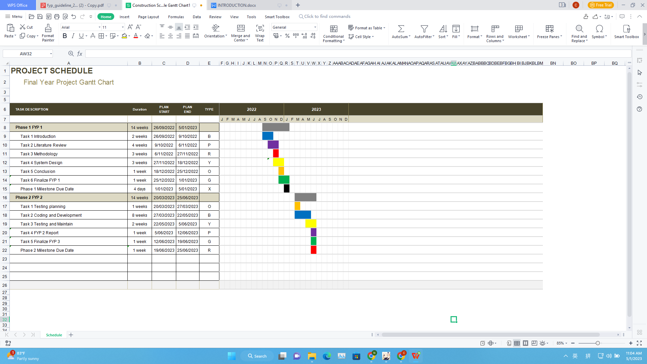

**Figure 1.5.1**

Figure 1.5.1 is gantt chart which include the whole development schedule of this project, FYP 1 one be focus on analysis and system design, FYP 2 will be focus on development and testing.

# LITERATURE REVIEW

**2.1 Introduction**

Computer centre is very common nowadays, they appear in many places like, hotel, shopping mall, independent computer centre, etc. Therefore, there are many computer centre of different sizes or with different additional services. Some sell food and drink, some don't, some seats are inside a room, some seats are public. So need a simple reservation system to help the staff and customer to have ease experience.

Different size of computer centre will have different seats, some of them may also have second floor or third floor, so a simple reservation system will help to show all the seats available for the customer and help the staff to manage and record which customer having which seats. Some simple contact number also improve communication experience between staff and customer.

For some small size computer centre, when a customer when to the computer centre to book for seats, they only need to tell the staff which seat they want, how long they want to rent and pay for the cost, and the staff just unlock the related computer for them. But if anything happen to the seats and the customer already leave, the computer centre can do nothing. For the customer, they don’t have any record that they pay for the hour, so if the computer suddenly lock, they also have nothing to prove. So reservation system not only help to improve the experience of the customer and staff, it is also a way to protect the interests of both parties.

For other computer centre who do not have a reservation system, they may record all the information manual, either key in the computer manually or write on a paper, these way causing too much time to record and arrange. For the paper record, it even generate a lot of files, it is hard to have a backup and maintain a large amount of documents.

In this era, there is numerous reservation systems, so in this project will studies some other project reservation system, learn all the feature and function that may suit to this project. The next part of this chapter will discuss and compare all the feature among all researched project as the improvement to this project.

**2.2 SENET**

Our vision at Senet is to transform the gaming industry by empowering Esports arenas across the globe and to make Esports a hot commodity((n.d.). Who we are. SENET. https://senet.cloud/en/about#company). SENET is an internet cafe reservation system, it has different price with different permission and function provided, you can email to them to ask for a trial to test out the function.

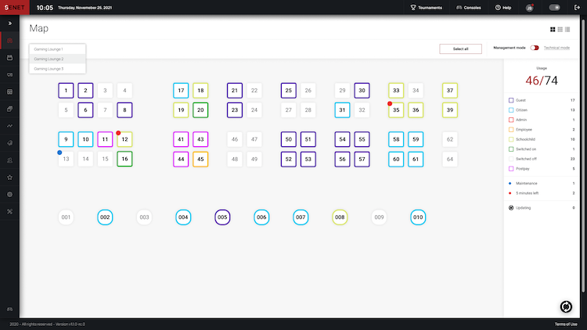

**Figure 2.2.1**

This is the computer management interface of SENET. You can create different lounge and manage all the computer in one system, there is a list at right side to show all the status of the computer, which are using by guest, by citizen or even using by admin or employee. Different colors means the computer is under different status, the computer with green label mean the computer is switched on, but there is no user, so the employee may go to switch off the computer to prevent waste of electricity. The list specify the group clearly to have a better management and analysis. There is also a red dot on top of the computer icon which mean the computer reservation is 5 minutes left, and for blue dot means the computer is under maintain, so it is easy to manage all computer. The administrator also have the permissions to check all the remainning reservation time for the computers.

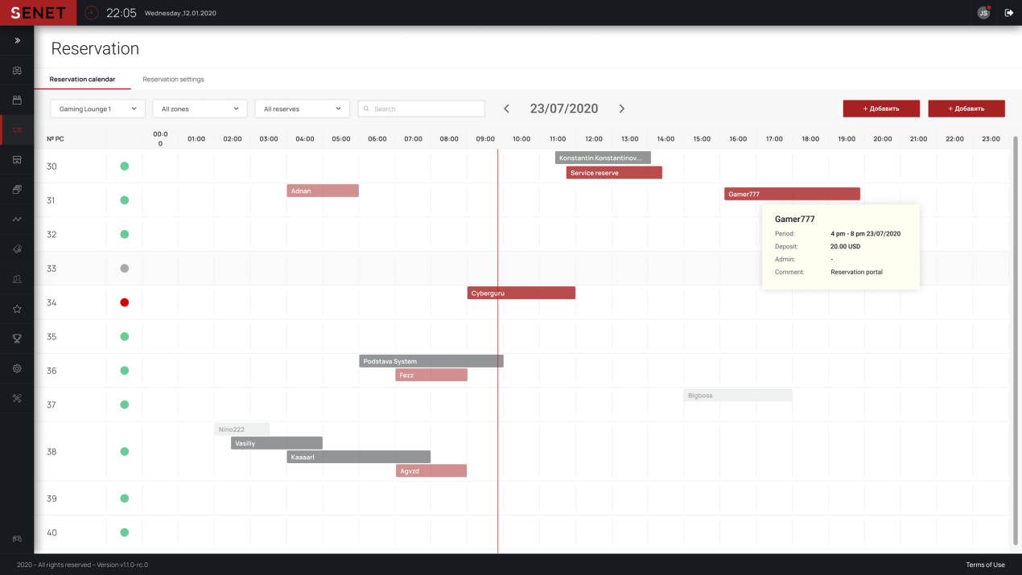

**Figure 2.2.2**

This is the page that show all the reservation of all the listed computer with listed time, the user can track the reservation with this schedule, they can also check who are the one book for the reservation, how much is the deposit, admin have the permission to manage the reservation to prevent any accident happens.

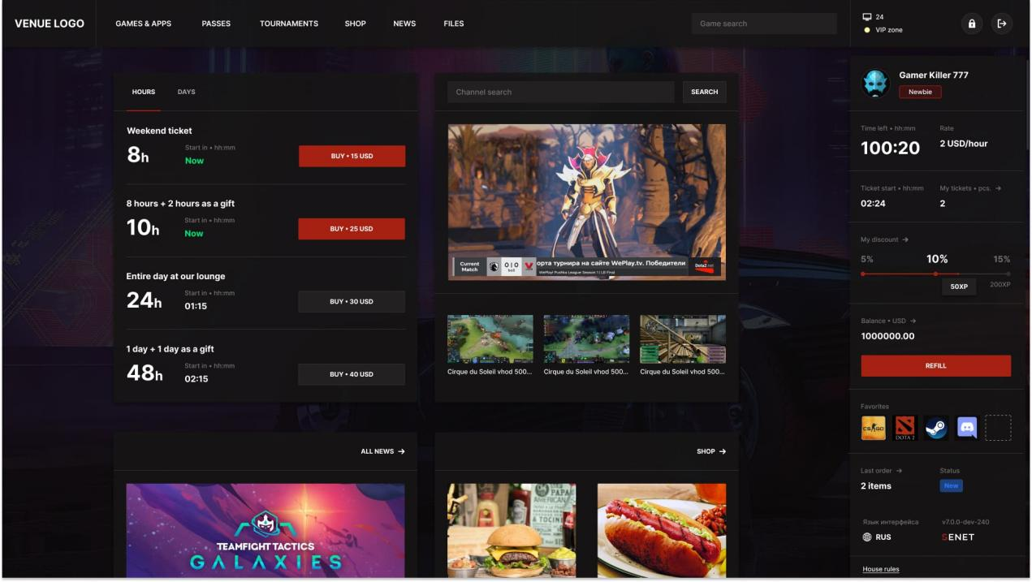

**Figure 2.2.3**

FigureXX is the interface of the user, the user can track all the information of their reservation in this page, their username, id, the remaining time of their reservation, their balance. SENET also provide a way to reward frequent visitors, the user will have some discount if they accumulated points. This feature can increase the loyalty of the visitors. At the bottom side will provide some news of the internet cafe and food and drink order, user can order food and drink when they are using the computer. User can also extend their reservation easily in this page, the price to extend how long are also show in the top left of the page.

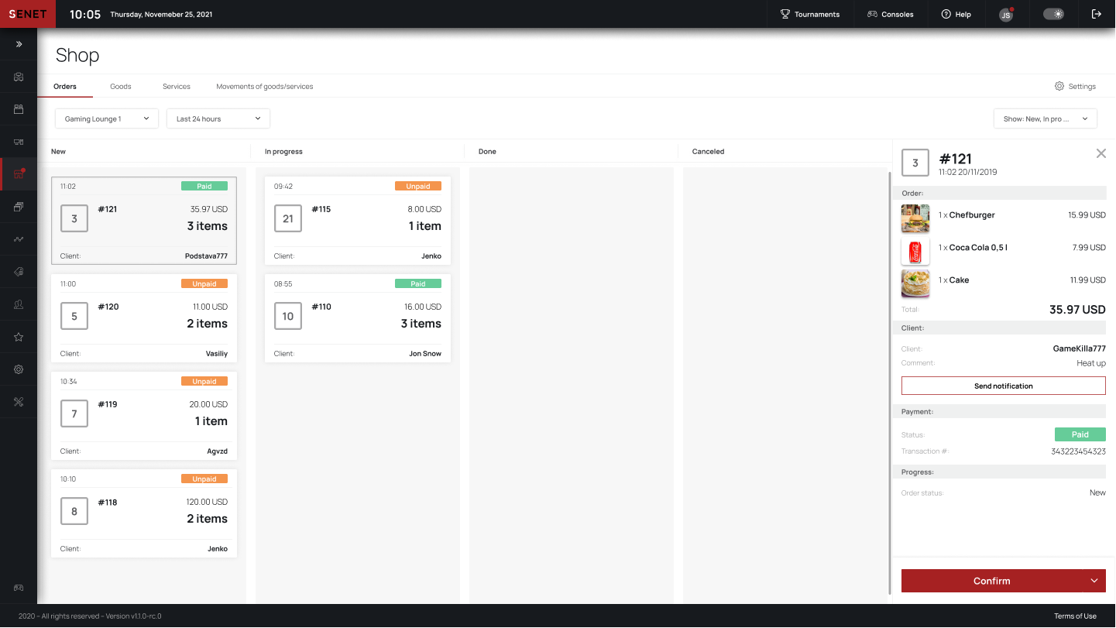

**Figure 2.2.4**

This page is the order track for admin, employee will receive notification whenever any order is made by the user, all the order will show which computer user is ordering, this function is ease for both customer and employee, the customer and order food and drink while they using the computer and the employee can track who ordered, sent the order easily. Employees can track all the order here to know which order is done and which is not. They can also track the order is canceled, paid or still in progress. This improve the convenience and efficiency of the order.

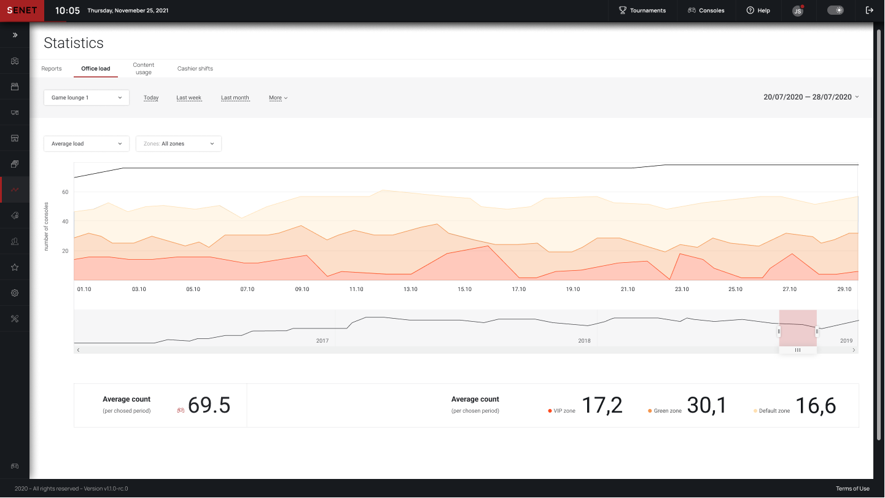

**Figure 2.2.5**

SENET will automatically generate financial report and collect data on customer usage. With the report, can easily review and analysis all the customer flow peak, and execute some business strategy to improve the visitor of the centre.

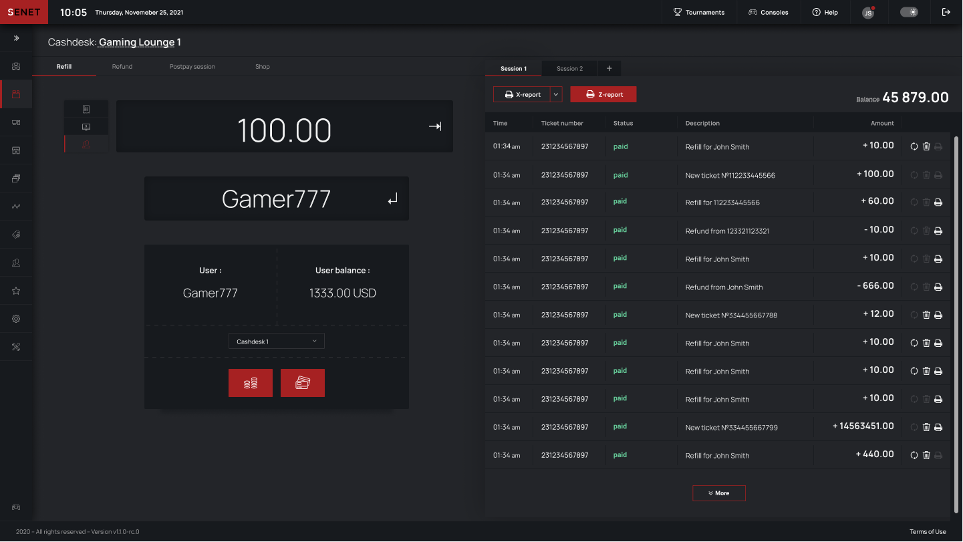

**Figure 2.2.6**

Figure 2.2.6 is the cash desk of SENET, all the transaction will be record here, any payment done will be record in the system with detail information, and the admin can generate the log of all the transaction done for further management. Admin can also track the user account, show their balance, and may help them top up balance or use their balance for further payment.

SENET is designed to simplify same operations of staff managing dozens of computers, user can have their personal account and having discount or bonus in the internet cafe. SENET also simplify the communication between customer and employee, all the movement can be done in SENET, booking, order and also payment.

**2.3 Antamedia**

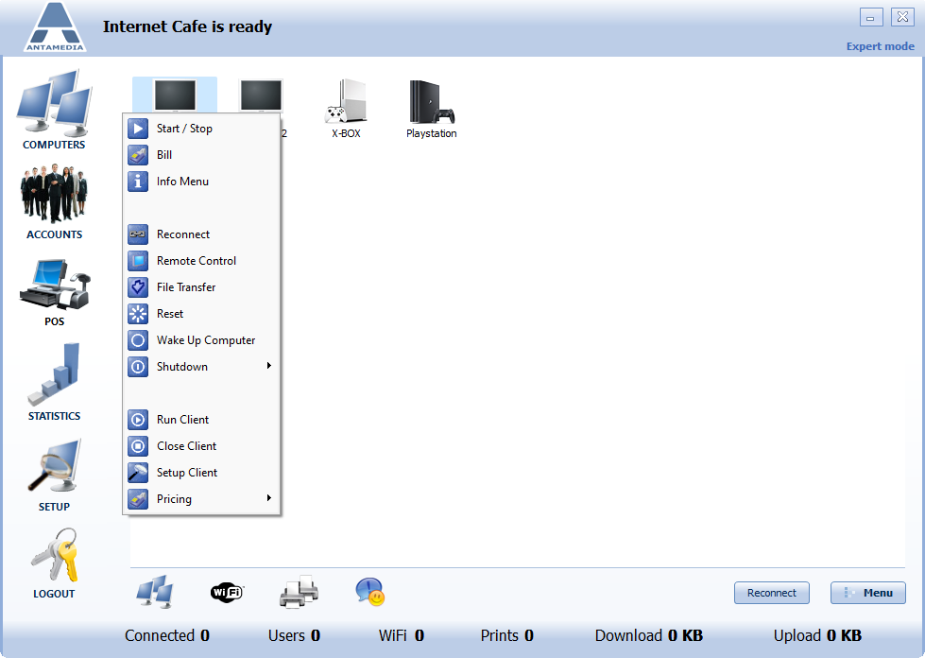

**Figure 2.3.1**

Antamedia Internet cafe reservation system. Figure 2.3.1 is the interface of the Antamedia, Staff can track and manage all the computer in this interface. They can control all the clients with the main server computer, the main computer can turn on and turn off all the computers in one click. The main computer can also remote control or send the file to the selected computer. These functions let the staff have better control of all the devices in the centre, but if the computer cannot be turned on by the new user, and the staff also forget to do so, it may cause some argument, because any delay may affect customer mood and feeling.

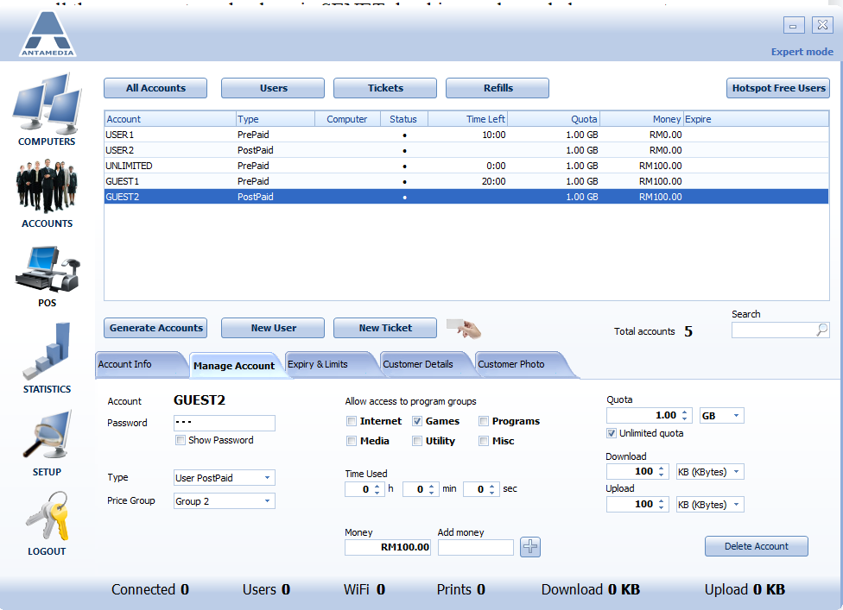

**Figure 2.3.2**

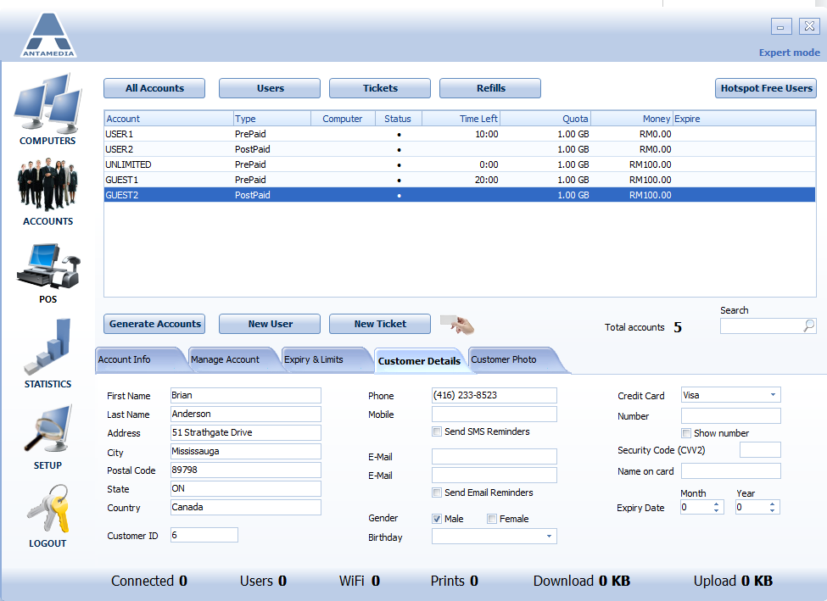

**Figure 2.3.3**

User accounts are added by the admin, admin can modify all the information for an account. All the reservations are made by an account, user accounts have balance and can top up to have easier payment. Staff can generate a ticket for the customer who doesn't want to create an account here. The client side has a login method using ticket to login, the ticket is a prepaid based access code. If the customer wish to extend their time of reservation, need to ask the employee to update their account and extend the time.

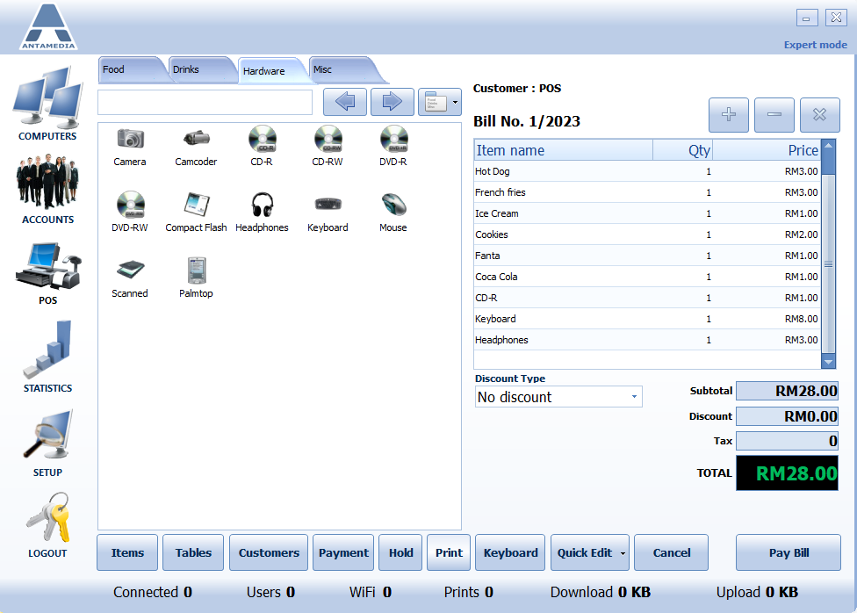

**Figure 2.3.4**

The application also provide the snacks and drinks order function. In the application, admin not only can setup food and drinks, they can also sold other item like CD-R,DVD and other hardware. All the information can be update in the setup tab. After the order is done, the total price will be calculated, beside also provide a discount function to give some discount to the VIP or other roles. But all the function are only available to the admin, customer can order to the employee, and the employee will enter the requirement of the customer to the application, the function is more like a cashier.

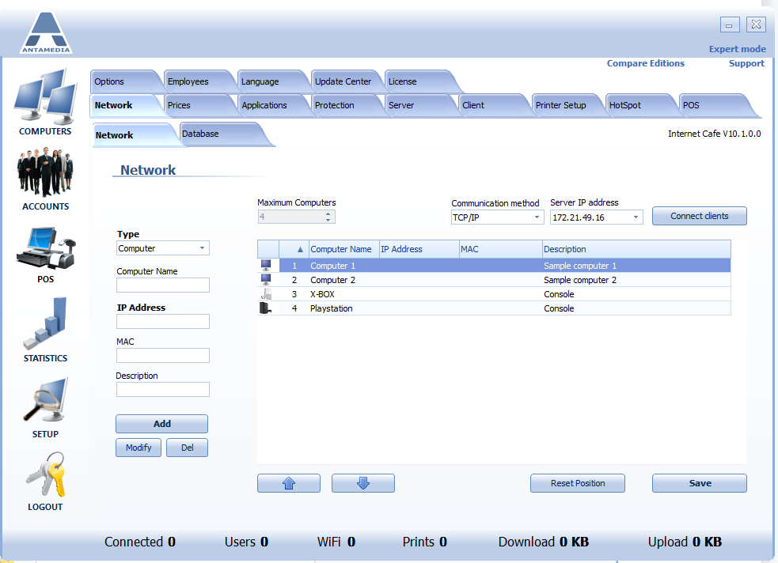

**Figure 2.3.5**

The way to add computer or other devices,admin need to go to the setup, then network tab. In here admin can add the computer or console and setup the IP address and mac address in the setup page.(this is the trial version so the maximum devices is 4).

This application can also set up printers, also a good device that supports workers or students to print the document out l after finishing the work.

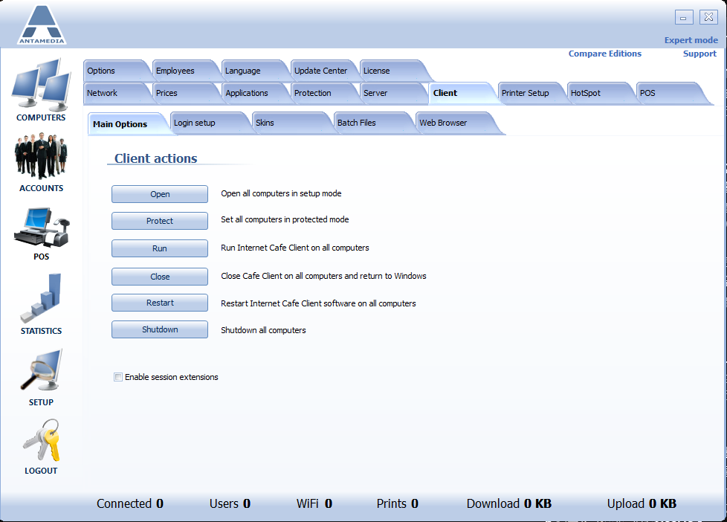

**Figure 2.3.6**

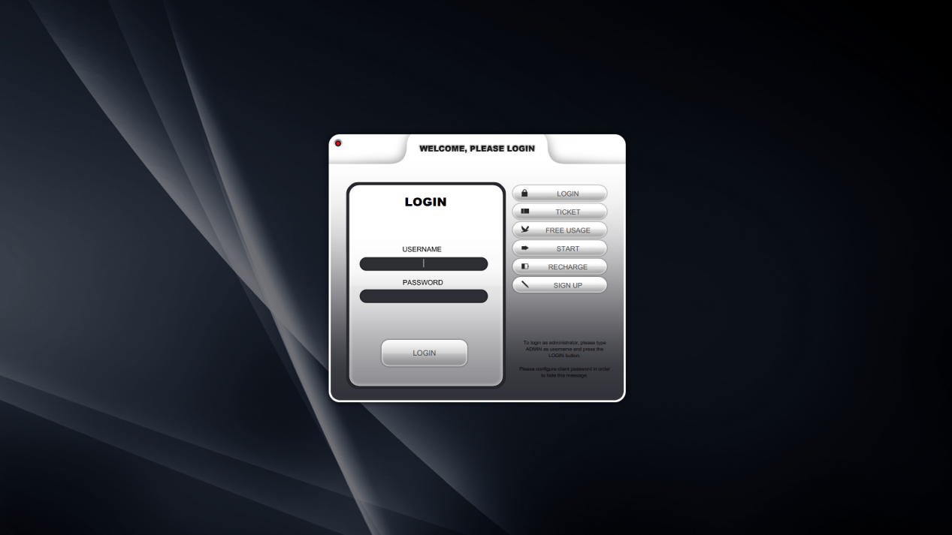

**Figure 2.3.7**

This reservation system comes with two part, one is the server side which is install in the main computer to control the whole centre devices, in figure 2.3.6, admin can one click to control all the client side computer. Another part is the client side which install in the computer that wish to control. Customer need to create an account at the server side, after the employee helps to create an account and book for a time to use the computer in the centre the customer with the account can login to the computer with the account username and password. If the customer do not want to create an account, they will need to book with the employee and the employee will generate one-time ticket and let the customer to login to the computer with the number on the ticket.

The functions of the Antamedia are complete, the whole setup is common nowaday at most of the internet cafe, because the server and client are working in their own server, user cannot access to the server if they are not in the internet cafe. One shortcoming is the interface is not user friendly, it contains too many explanation word and the design have the similar theme as window 7, also there is no any guideline to show how to add a computer, how to modify the information or the computer. User accounts can be modified and added in the accounts interface, but the computer modifications are done in setup>network, not computer. The computers tab is only to manage the devices that already added from the setup tab.

**2.4 Pancafe pro**

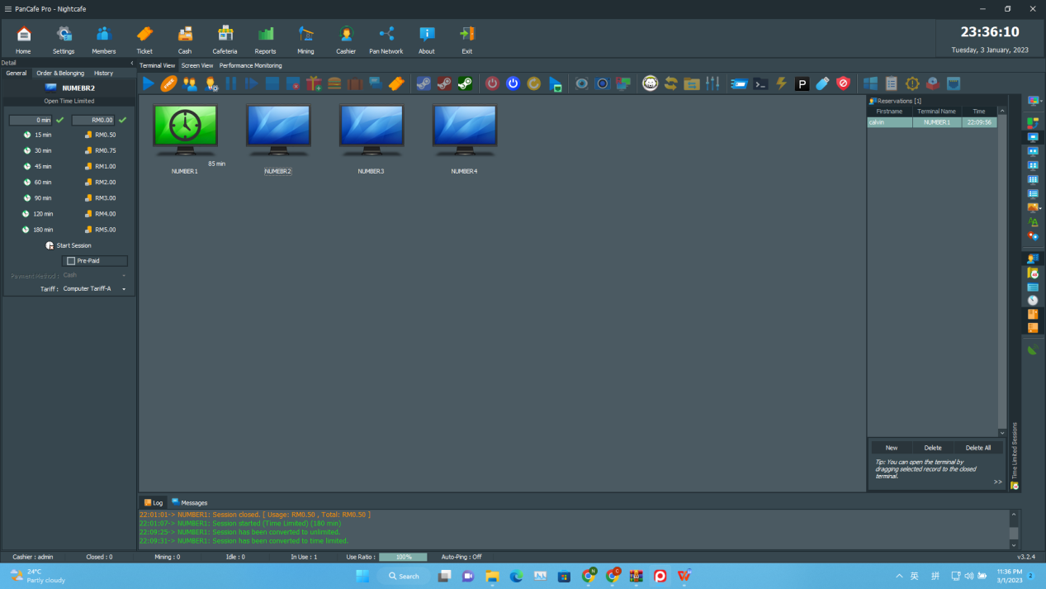

**Figure 2.4.1**

Pancafe pro is another cyber cafe reservation system, it have all the basic function as the previous two studied system, it also have the user account create similar as the Antamedia, all the account create, control are done by the server side computer which manage by the employee. But pancafe pro have some unique feature that previous system doesn’t have

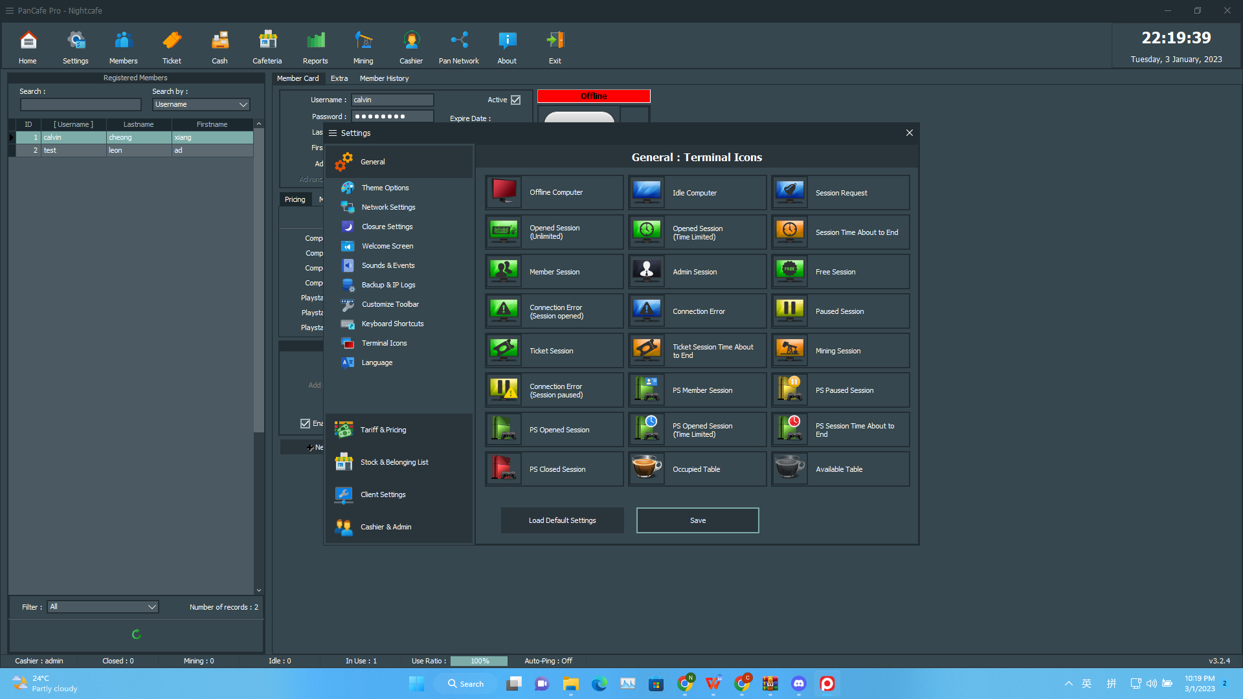

**Figure 2.4.2**

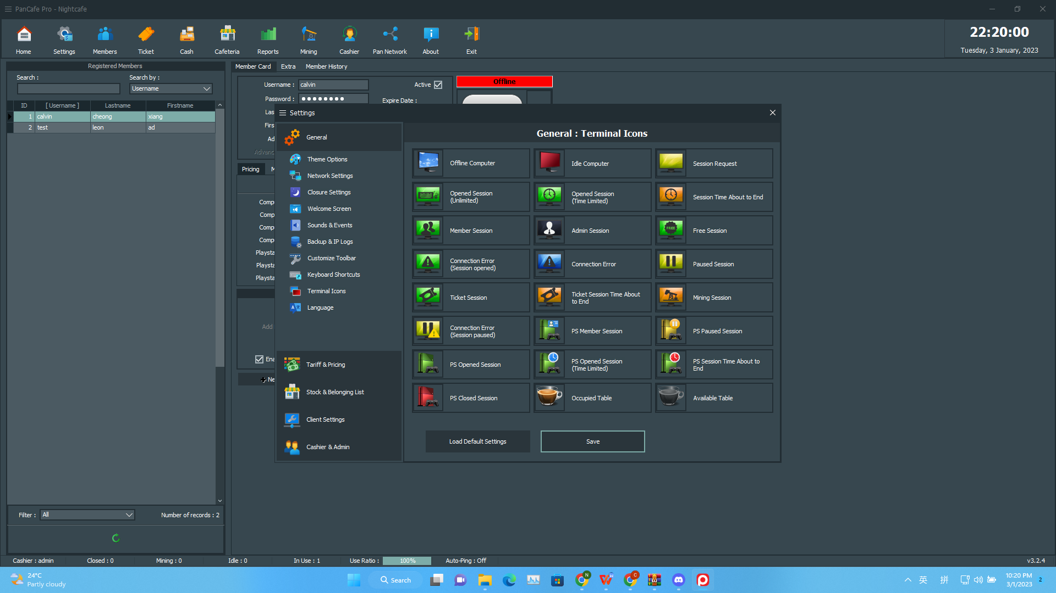

**Figure 2.4.3**

First one is the icon flexibility, pancafe pro have many icon and chroma this make the admin can modify the best icon and color to help them differentiate all the status.

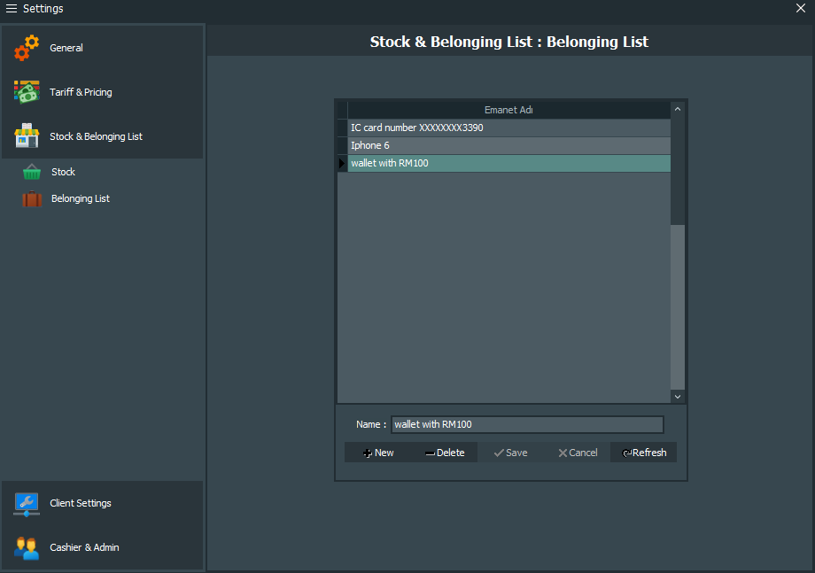

**Figure 2.4.4**

Another one is the belonging list, This function may not be commonly used, but it will definitely be used in the Internet cafe reservation system. Many customer when to the cyber cafe for relax, some of them go for work, but most of them will be too relax or too focus on the work. If all the payment are done, most of the customer may just leave the cybercafe without checking their seats when the time is up. So this function can help the employee to record what have been drop, this also prevent any argument happen when they comes.

**2.5 Comparison among all the researched system**

All the system studied are complete internet cafe reservation system, each of them can fulfill different size and requirement companies to improve their business.

For Antamedia and Pancafe pro both of them are free to use, all you have to do is follow their step and you can get a free application to use, but both of them have some limitations, user cannot register an account by themself, all the account settings are done by the admin which is the employee, this makes the employee have one more work to focus and manage. All the settings are group together in one tab and the interface design are complex and not attractive. But both Antamedia and Pancafe pro still have all the requirement for a basic cyber cafe reservation system.

For SENET, it have better review overall the system, the interface is simple, and the design is attractive, have all the function provided but the interface are clean to use. It also have a better interactive between user and admin, customer can register their account by themself, and all the reservation, order and payment are able to done by using the account. As good as SENET is, they still require a monthly subscription to use their service app.

Table below show some comparison the features among 3 reservation system

|  |  |  |  |
| --- | --- | --- | --- |
| Features \ System | SENET | Antamedia | Pancafe pro |
| User can register account without admin | tick and cross | tick and cross | tick and cross |
| Server can be access outside the centre | tick and cross | tick and cross | tick and cross |
| Console reservation beside reservation for PC | tick and cross | tick and cross | tick and cross |
| A schedule list to check all the reservation | tick and cross | tick and cross | tick and cross |
| Food and drinks selling function | tick and cross | tick and cross | tick and cross |
| User Friendly design | tick and cross | tick and cross | tick and cross |
| Belonging lost list | tick and cross | tick and cross | tick and cross |
| Security | tick and cross | tick and cross | tick and cross |

**Table 2.5.1**

In conclusion, the design of the Pancafe pro and antamedia are more suitable for small medium enterprise, they have all the function need to manage a cyber cafe, and the requirement of the system to run application also lower. For SENET it is better use to manage a larger cyber cafe, It have all the process need to track and take care of every customer, customer can also use their account to have a ease communication with the employee. SENET also have all the statistic and record to help the company to improve their business plan or expand branches.

**Chapter 3**

**Methodology**

**3.1 Software development life cycle**

Software development life cycle also known as SDLC is a very important process when developing an application-based project. A good SDLC implementation can decrease the risk of the project and cost of the project. It also implements the planning and scheduling of projects to better control estimated times while meeting client requirements((n.d.). SDLC. Synopsys.).So it is very important and must involve in this project. In SDLC, there are several phase to finish a project:

**Planning**

The first phase of SDLC is planning, this phase is to identifies all the requirement of the system. The requirement define not only focus on the development of the project, determination of which systems to develop may also affected by ad hoc user requests as the need for new system. In this project, will be identifies working plan, software development tools and hardware that require to develop the system.

**Analysis**

Second phase is analysis, this phase is to determine all the requirement. Developer will have some research about some other similar project to study what process and function they involves, also learn about needs’ of the users. This phase may help to prevent many shortcomings, or having some idea to replace or enhance when developing a system. In this project, some similar project are studied in the last chapter.

**Design**

Third phase is Design, this phase is to implement all the requirement research done in phase 1 and 2 into logical and then physical system specifications. This phase also help all the developer have the same final logical view, function, programming language use to develop, etc. of the system. Some of the design of this project are discuss in the later chapter.

**Implementation**

Fourth phase of SDLC is implementation, this phase will start to develop the system according the design in phase 3. Coding, testing, installation are involve in this phase. This project will start this phase in FYP 2.

**Maintenance**

Last Phase, maintenance the system. When a system is finish development which also is the phase 4, it will start to service users. Sometimes users may have some feedback about the system, maybe some bug or some recommendation. So in this phase is let the developers to perform modification to improve the system. This phase will involve in this project in FYP 2.

SDLC have shown 5 phases when it involve in a project but there are different type of SDLC. Different SDLC have the same phases but different characteristic.(George, J. F., & Valacich, J. S. (2017). Modern systems analysis and design (8th ed.). Pearson Education Limited, Harlow, Essex, 2017.)

**3.2 Comparison of different SDLC**

**3.2.1 Traditional Waterfall SDLC**

This SDLC phases is run as ”downhill” which mean one phase is completed or reached, the project proceed to the next phase. In this SDLC it is very difficult to go back to the last phase when the new phase began, if go back will cause a high cost. The requirement and implementation will define in their phases and hard to change so the project using traditional waterfall SDLC will have a smaller system user or customer role. The goal of this SDLC is develop a project from the customer requirement and hand over it when the deadline come.(George, J. F., & Valacich, J. S. (2017). Modern systems analysis and design (8th ed.). Pearson Education Limited, Harlow, Essex, 2017.)

**3.2.2 Agile Methodologies and eXtreme Programming**

Both SDLC have a basic cycle of all phases, but these SDLS have combine analysis,design,code,test in to one process, which mean the project system functions, advantages, disadvantages are also learn in the process of developing a system.

Agile Methodologies is recommend for the project involves, unpredictable requirement, responsible developers.

eXtreme Programming is recommend for the project have short, incremental development cycles. It emphasis on two person programming teams and focus on automated tests written by programmers.(George, J. F., & Valacich, J. S. (2017). Modern systems analysis and design (8th ed.). Pearson Education Limited, Harlow, Essex, 2017.)

**3.2.3 Conclusion**

Traditional Waterfall SDLC is better for computer centre reservation system compared to eXtreme Programming and Agile Methodologies, because this project have a clear goal and user, also it involve a long development and one person programming. It is better to implement and learn all the requirement of the system only start to development.

**3.3 Development hardware & software requirement**

This project will be running HTML as the main design language php as the main programming language and run in the local server setup by xampp.

Minimum System Requirement

|  |  |
| --- | --- |
| Operating System | Windows 7 |
| Memory | 2 GB Ram |
| Processor | Intel Pentium 4 processor |
| Keyboard | 105 keys |
| Mouse | USB mouse |

Table 3.3.1

Software requirement

|  |  |
| --- | --- |
| Coding development | Notepad / Notepad++ / Visual Code Studio |
| Browser | Google Chrome / Microsoft edge |
| Local Server | Xampp |

Table 3.3.2

**3.4 System development language**

This project is a web-based application development, so there will be several computer language involve in this project.

**HTML**

First one will be the design language, Hypertext Markup language which also known as HTML. According to a survey from Stack Overflow HTML is the 2nd most commonly used language in 2020(Stack Overflow’s 2020 Developer Survey). It is a markup language heavily utilized for creating web pages and web application, markup language is different with programming language, programming language use to modify data, but markup language is to determine how elements are displayed on the page. HTML have a simple structure that easy to understand.(G. B. (n.d.). Web development. Global Media Insight.)

HTML file of a website keep in their own server, whenever you visit their website, the server will send the HTML files to your browser and the browser will reads the HTML file and display the website, their server may also have many image inside, because HTML not only can display text, it can also display image on the website.

HTML is not a programming language, so it cannot modify data, it also can not take any input and output, so if want to have any calculation, modify or input output data will have to implement other language like, PHP, javascript, etc.

**CSS**

HTML can display text, image, but all the elements have less display type like colors, fonts ,etc. So HTML commonly embedded by a style sheet language call Cascading Style Sheets, CSS. Style sheet language is use to produce different presentation style for other language, and CSS is used to style the documents written in HTML. The size, color, font and also positions of all elements in a HTML web page can be determined by CSS.Therefore CSS helps web developer to design the interface easily.

**Javascript**

Javascript also abbreviated  as JS, is an OOP scripting language which only run on a browser. Javascript alsos is interpreted language, therefore it does not need the time to compile code. Javascript not only support HTML in web development, it can also be used for develop mobile apps, games and web servers. Javascript is a most commonly used programming language in the world, in 2022, 98% of the websites use JavaScript(Stack Overflow’s 2020 Developer Survey). One of the reasons for its popularity is that it can be used for both frontend and backend web development. Javascript’s syntax is very simple and easy to learn, it also have many features, it can validate user input to ensure the format is correct, this can help to reduce any redundancy or useless data. Implement Javascript in this project to capture the correct format of user input.(G. B. (n.d.). Web development. Global Media Insight.)

**PHP**

PHP or Hypertext Preprocessor is an open-source scripting language used for embedded into and support HTML in web development. It is one of the most popular web page language, one of the reasons is it supported by many third-party extensions like .NET, MYSQL and Apache.With PHP you not only can modify the file on the server, you can also modify data connect to a database, it can also help to encrypt data. PHP is focus on server-side scripting, you can use PHP parser and run PHP programming on the browser with the local web server setup by Xampp in your computer. PHP is not limited to output HTML, it can also output PDF, animation, images, text,etc.(G. B. (n.d.). Web development. Global Media Insight.)

**Mysql**

Mysql is an [open-source](https://en.wikipedia.org/wiki/Open-source_software" \o "Open-source software) [relational database management system](https://en.wikipedia.org/wiki/Relational_database_management_system" \o "Relational database management system) (RDBMS). Relational database organizes data into one or more data tables in which data may be related to each other, these relations help structure the data. This language is easy to learn and use. Mysql can connect with the PHP using a free and open source administraton tool call phpMyAdmin. With Mysql, all the data can be store in the database accordingly, it is a good way to manage all the data information.

**CHAPTER 4**

**SYSTEM DESIGN**

**4.1 SYSTEM FUNCTION**

This project is about computer centre reservation system, so it involve different permissons to customer and employee:

Register & Login:

In this phase, new user will have to register an account to have access to the service of the system. The user who had already registered before can login to the system with the username and password they use to registered. For the employee, they will provided an admin account, so they need to use admin account to be on duty

Account:

When the user register they will have the control of their account to access the service, they can also modify their username, phone No. Etc, information or even delete their account. For the employee, they will using admin account, admin account has the permission to modify other users account, to prevent any trouble makers.

Schedule:

System will have list out the schedule of each computer’s reservation, what time have been book by another customer, when is the computer available today. This function can help the customer to adjust their time, also can book the computer for further reservation. Admin can modify the schedule of the computer when ever any accident happens.

Reservation:

The system will list out all the computer in the centre with all the information, the price booking for how many hours. Customer can check the information and made booking anywhere anytime. For the admin account, employee can modify all the information of the computer, if one of the computer is broke admin can change the status of the computer to unavailable. For the customer visit but do not have account, employee can also book the computer for them with the admin account.

Drinks & Snacks

User can use the system to check the information of all drinks and snacks that available in the centre, they can order the drinks and snacks anytime by using the system. For the admin account, employee can modify all the information of the drinks and snacks. Also they can clear the order of the customer when the drink or snack arrived.

Payment

User will have a list of all the expense they spend today, all the information will be listed, how long their reservation, how many drinks are ordered, total price, etc. they can make the payment using the system.

**4.2 Context Diagram**

This project is Computer Centre reservation system, so the main user, one will be the customer as user , another will be employee as admin to manage the whole system.All the information will send into the computer centre reservation system. This is the context diagram of the system.

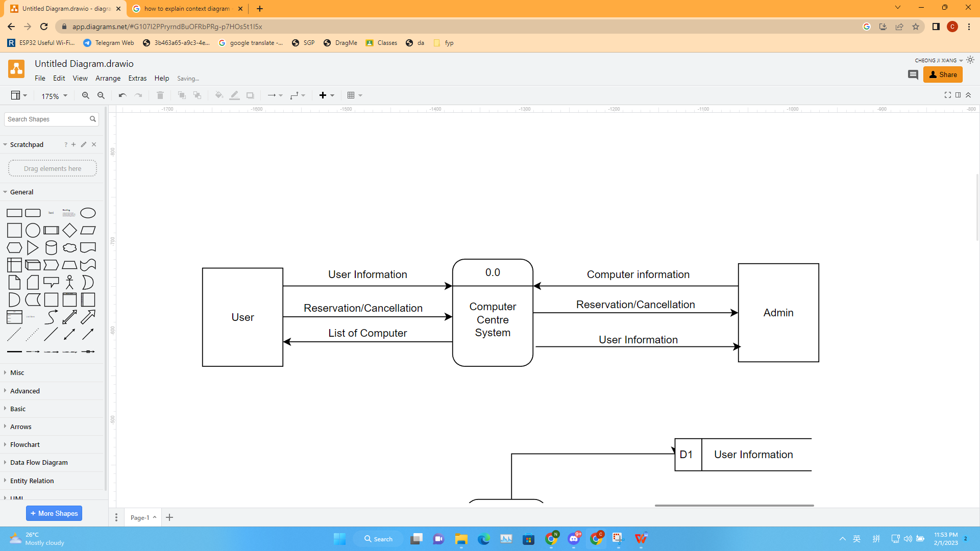

**Figure 4.2.1**

**4.3 Data flow diagram**

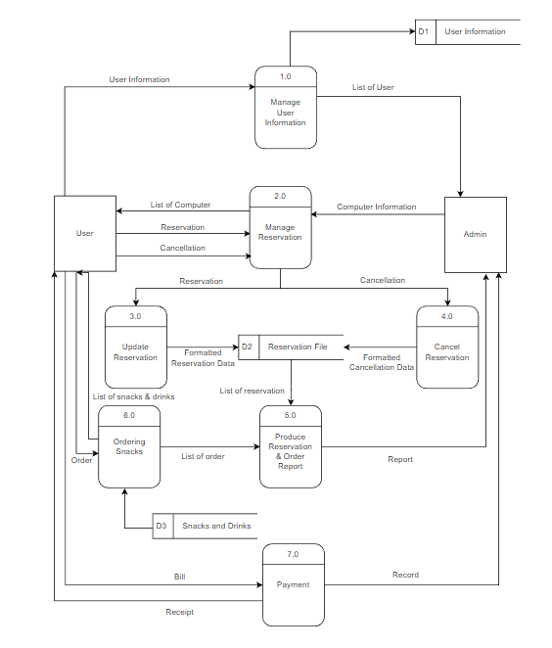

**Figure 4.3.1**

Figure 4.3.1, is a level 1 data flow diagram of the system, main character will be customer as user and employee as admin. User will need to register to the system, and the system will manage and record all the user information and store in a database. The password of the user will be encrypted and store in the database. The list of the user will be available at admin side.

User can access to the list of computer to check all the informations of the computer and make reservation or cancellation. All computer information are manage by admin, admin have the permission to modify computer information, as well as all the reservation and cancellation. After the reservation or cancellation are made, record will update and send to the reservation file database.

User can access the list of snacks and drinks, and make order from the system, all the information of the snacks and drinks are store in a database.

The list of reservation and order will update into a report and send to the admin for further manage.

Lastly, user will have a list of all the expense they spend, they can make payment in the system, after the payment is made, a receipt will send to them and record will generate and send to the admin.

**4.4 Entity Relationship diagram**

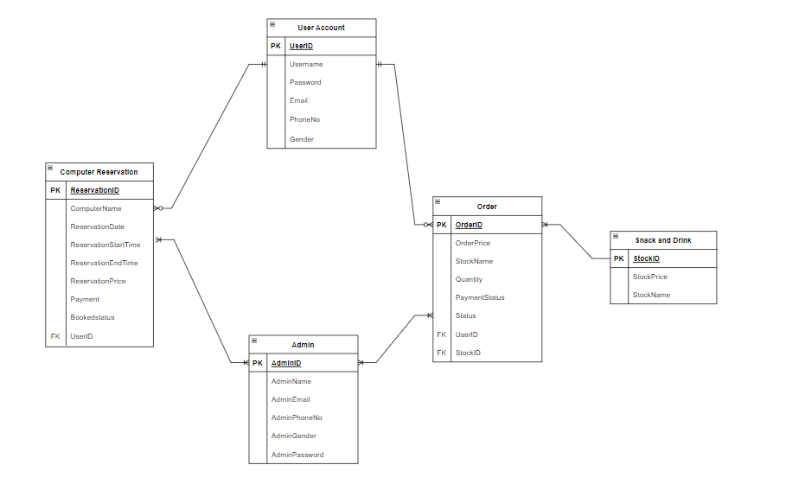

**Figure 4.4.1**

Figure 4.4.1 is an entity relationship diagram of the computer centre reservation system. All the relationship between each component are shown in the diagram.

An account will have many relationship,

An account will make one or more order, but an order is made by one and only one account.

An account and make one or more reservation, a reservation is belong to only one account.

An account can order one or more snacks and drinks, but one snack and dink is made by one and only one account.

Finally is admin, admin is control by employee, an admin is manage zero or more computer, and one computer is managed by one or more admin.

an admin is manage zero or more snacks and drink, and one snacks and drink is managed by one or more admin.

an admin is manage zero or more account, and one account is managed by one or more admin.

**4.5 Use Case diagram**

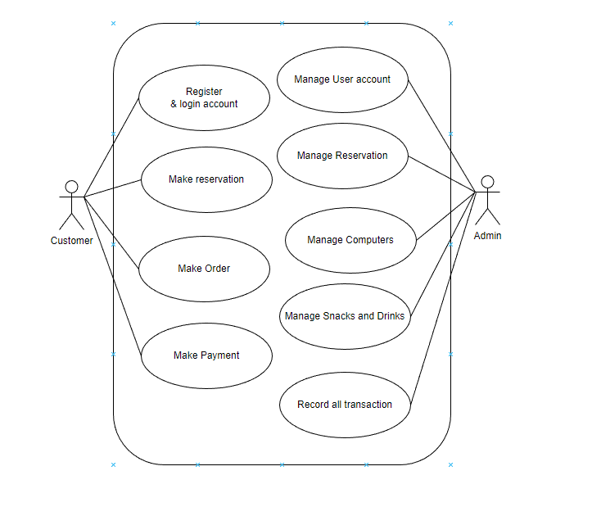

**Figure 4.5.1**

Figure 4.5.1 is the use case diagram of the system, Admin can manage user account, manage reservation, manage computer, manage snacks and drinks and also record all the transaction. While user can register and login with an account, make reservation to a computer, make order for some snacks and drinks also make payment for their expenses.

**4.6 Database**

**Database Name : CRS**

|  |  |  |  |  |  |
| --- | --- | --- | --- | --- | --- |
| **Column** | **Type** | **Length/Values** | **Key** | **Null** | **Default** |
| adminID | int | 255 | Primary | No | - |
| adminname | varchar | 255 | - | No | - |
| admingender | varchar | 255 | - | No | - |
| adminemail | varchar | 255 | - | No | - |
| adminphone | varchar | 255 | - | No | - |
| adminpassword | varchar | 255 | - | No | - |

**Table 4.6.1 admin**

|  |  |  |  |  |  |
| --- | --- | --- | --- | --- | --- |
| **Column** | **Type** | **Length/Values** | **Key** | **Null** | **Default** |
| Userid | int | 255 | Primary | No | - |
| username | varchar | 255 | - | No | - |
| gender | varchar | 255 | - | No | - |
| email | varchar | 255 | - | No | - |
| phone | varchar | 255 | - | No | - |
| password | varchar | 255 | - | No | - |

**Table 4.6.2 users**

|  |  |  |  |  |  |
| --- | --- | --- | --- | --- | --- |
| **Column** | **Type** | **Length/Values** | **Key** | **Null** | **Default** |
| ReservationID | int | 255 | Primary | No | - |
| computername | varchar | 255 | - | No | - |
| date | date | 0 | - | No | - |
| stime | varchar | 255 | - | No | - |
| etime | varchar | 255 | - | No | - |
| price | float | 0 | - | No | - |
| booked | varchar | 255 | - | No | No |
| userid | int | 255 | Foreign | Yes | - |

**Table 4.6.3 computers**

**Table Name 4: Stock**

|  |  |  |  |  |  |
| --- | --- | --- | --- | --- | --- |
| **Column** | **Type** | **Length/Values** | **Key** | **Null** | **Default** |
| stockID | int | 255 | Primary | No | - |
| stockname | varchar | 255 | - | No | - |
| stockprice | float | 0 | - | No | - |

**Table 4.6.4 stock**

|  |  |  |  |  |  |
| --- | --- | --- | --- | --- | --- |
| **Column** | **Type** | **Length/Values** | **Key** | **Null** | **Default** |
| orderid | int | 255 | Primary | No | - |
| userid | int | 255 | Foreign | No | - |
| stockid | int | 255 | Foreign | No | - |
| stockname | varchar | 255 | - | No | - |
| price | float | 0 | - | No | - |
| quantity | int | 255 | - | No | - |
| payment | varchar | 255 | - | No | - |
| taken | varchar | 255 | - | No | No |

**Table 4.6.5 orderdata**

**CHAPTER 5**

**SYSTEM IMPLEMENTATION**

In FYP phase 2, the system of the project is start to implement. The Computer reservation system is design for two types of users, one is customer who can book for a reservation as a normal user, the other one is employee who can manage the system as admin. This chapter will show all the screenshot of the system and explain each of them.

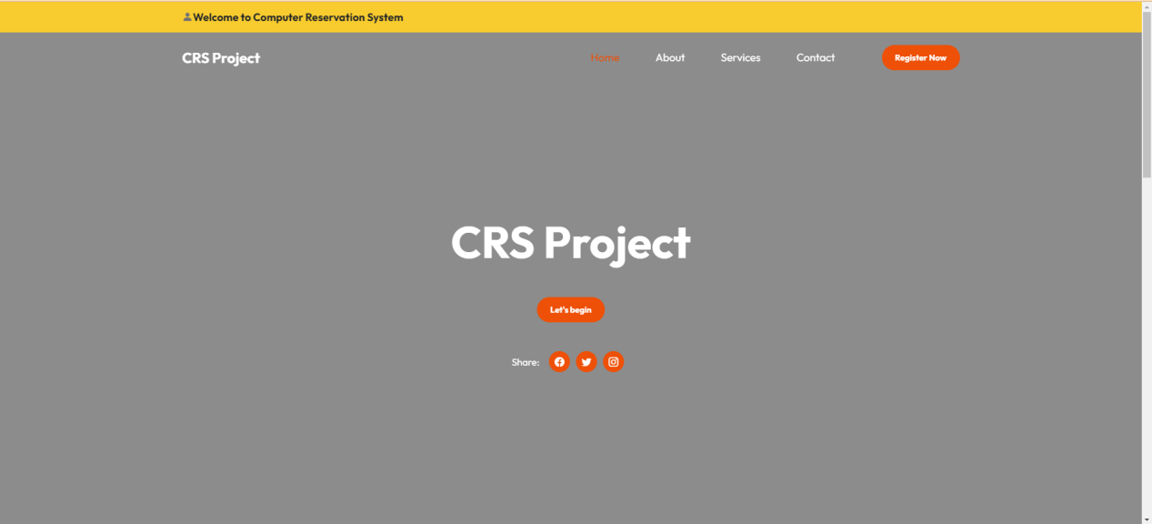

**Figure 5.1**

This is the index of the system, users start to use the system from this page. Users can know some information of this CRS Project.

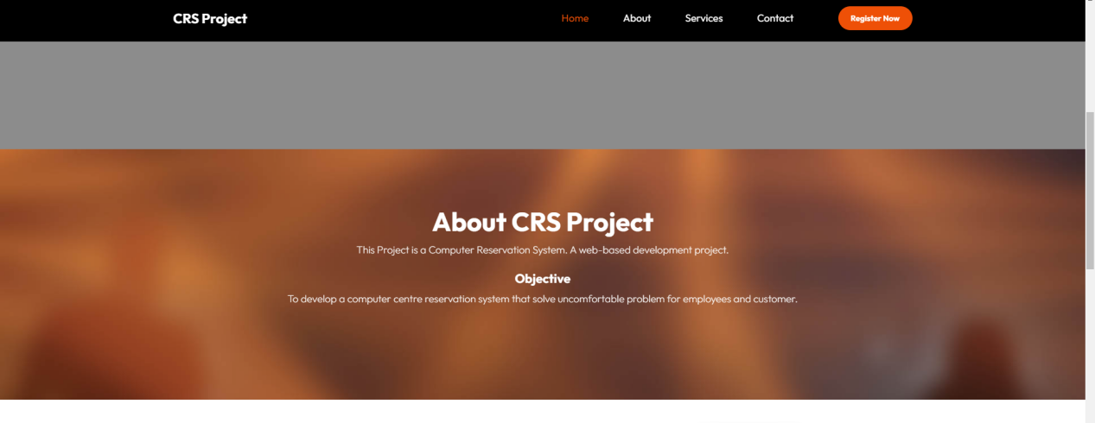

**Figure5.2**

About CRS Project. This Project is a Computer Reservation System. A web-based development project

The objective of this system is to solve uncomfortable problem for employees and customers.

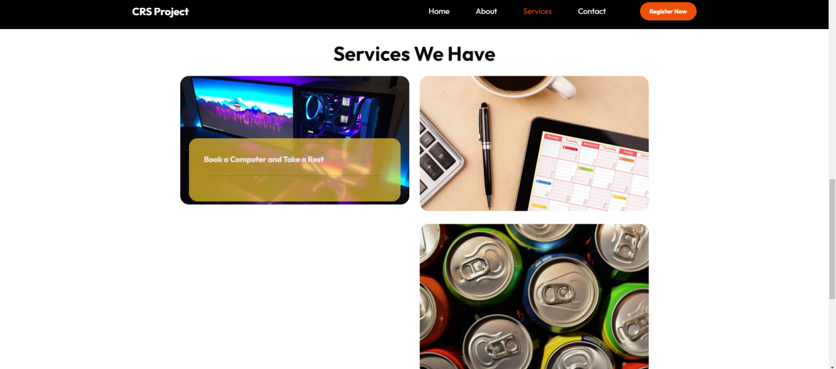

**Figure 5.3**

This system helps customer to book and reservation of a computer seat easily, anywhere, anytime. Customer can also order some snacks and drink when using the computers.

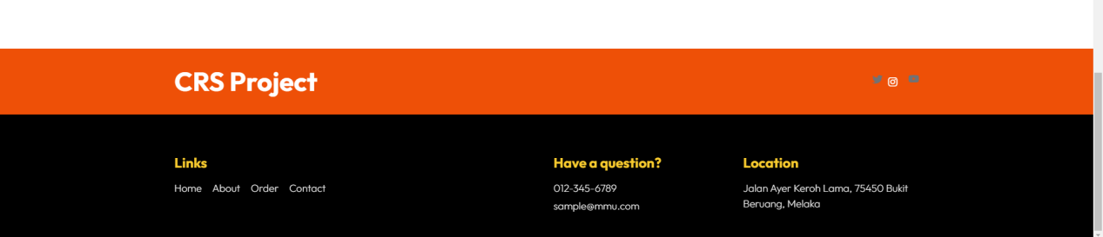

**Figure 5.4**

Figure is the bottom of the index page, here provide some information of the (sample)company.

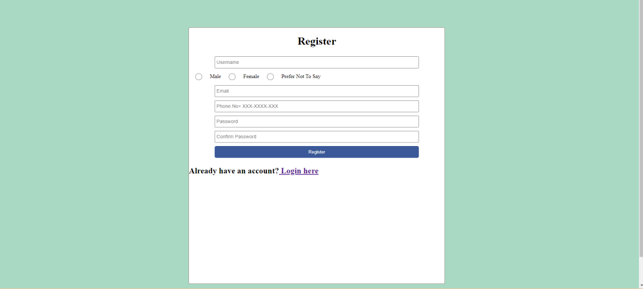

**Figure 5.5**

After click the ‘Register Now’ button, user will come to Figure page, this page allow user to register an account that use in the Computer Centre Reservation System. User need to provide some personal information to register the account. If the user had already register before and have an account, they can login with the “Login here” link.

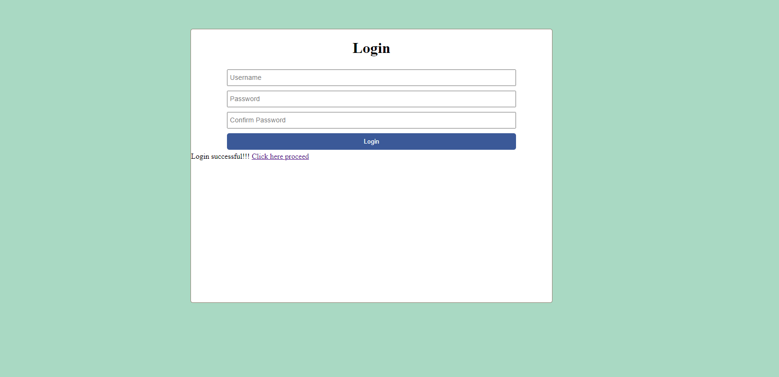

**Figure 5.6**

Figure 5.6 is the Login page for CRS project, user who registered an account can proceed to the main services by login with their username and password in this page. When the login is success, there will be a link call “click here proceed” appear and user can enter the system with their account.

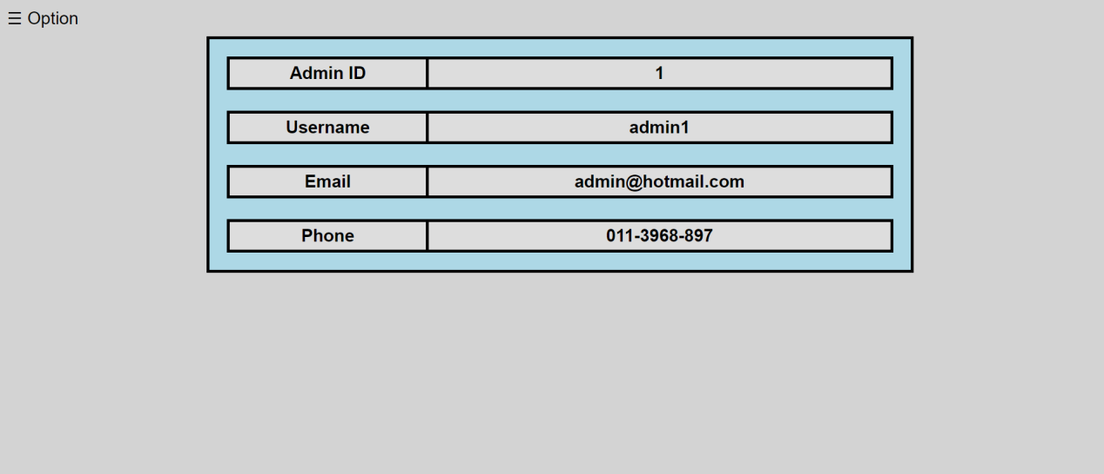

**Figure 5.7**

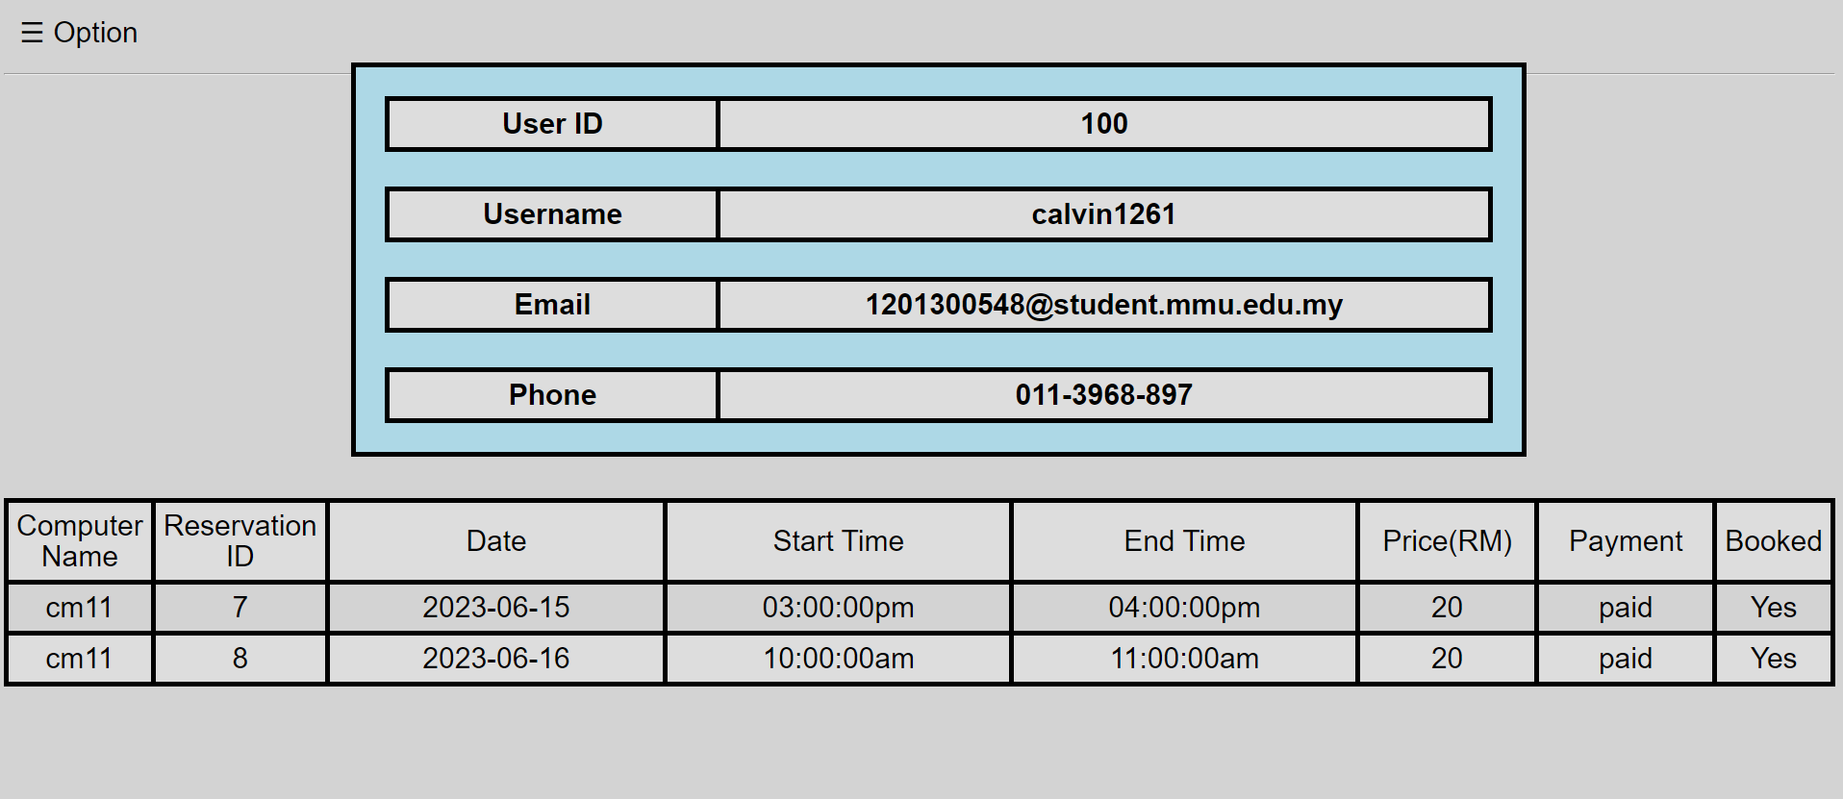

**Figure 5.8**

Figure 5.7 is the main page when admin is login and for figure 5.8 is the main page when user is login. This page show the information of user’s account. Top side show the information that user use to register their account, and the bottom side is showing their reservation details. The table will show the status of the reservation, the payment shows the reservation is paid or unpaid, if unpaid the user can cancel the reservation anytime, after the payment, user can no longer cancel the reservation. For admin page only shows the account information.

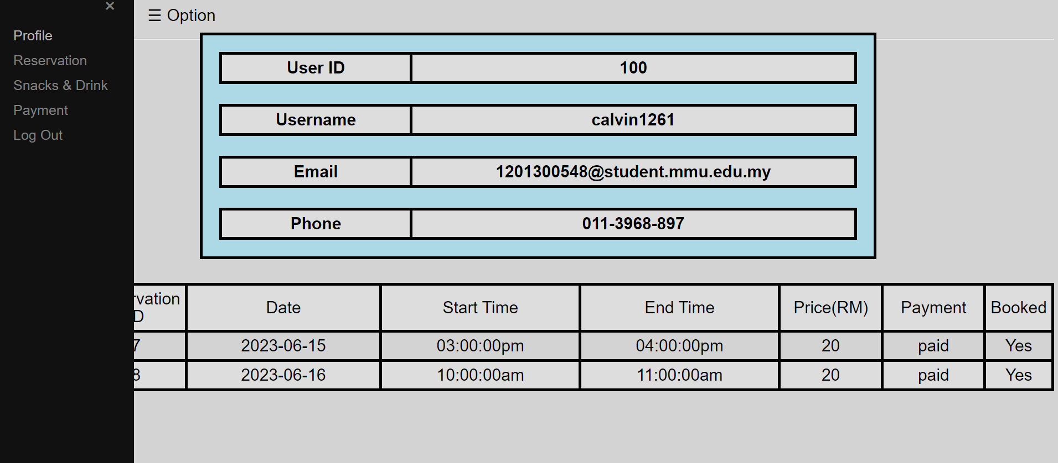

**Figure 5.9**

The Option side bar is available in all the pages, the side bar provide the link to all the services in the system.

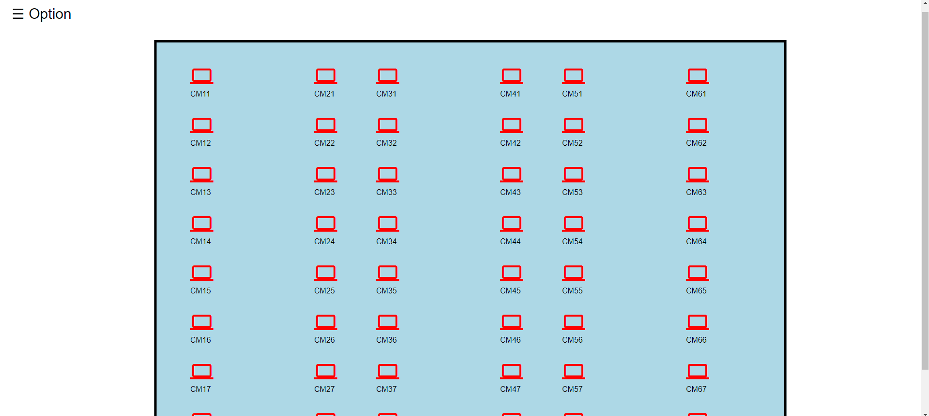

**Figure 5.10**

Figure 5.10 is the location map, user and admin can use this map to choose which computer information they want to check. Each computer have their own reservation and details.

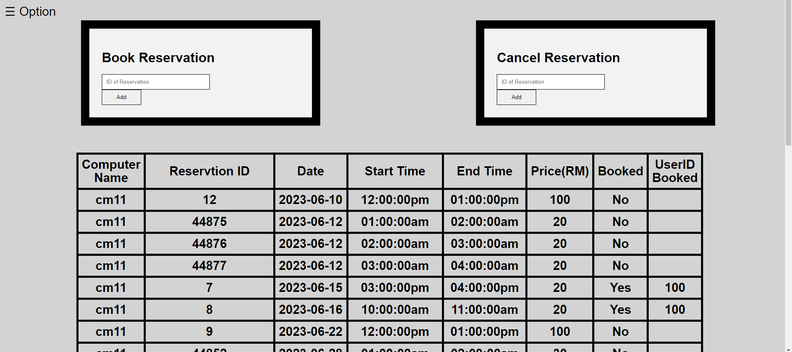

**Figure 5.11**

Figure 5.11 is the computer name cm11 which locate at the top left in Figure 5.9, when user click on the icon it will bring the user to this page which provide user to book reservation or cancel their reservation based on the schedule.

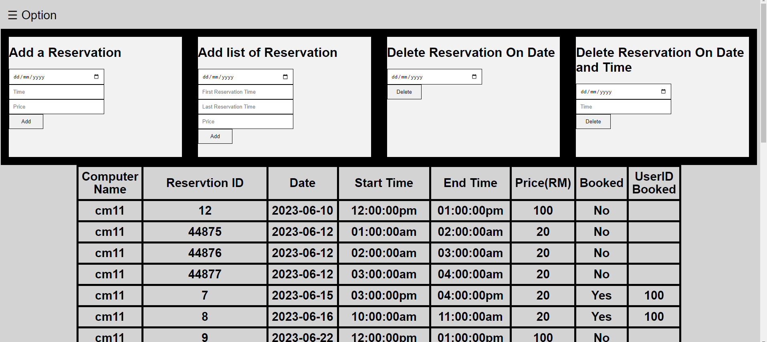

**Figure 5.12**

For admin when they access the cm11(same computer with figure 5.11), they will have 2 main function, which is adding a reservation for the computer, or delete the exist reservation. Admin can add one reservation with specific date and time, or add a list of reservation based of one date and the time duration,(each reservation are set to be 1 hour only). For delete reservation, admin can delete all the reservation in one date, or delete only one reservation based on date and time.

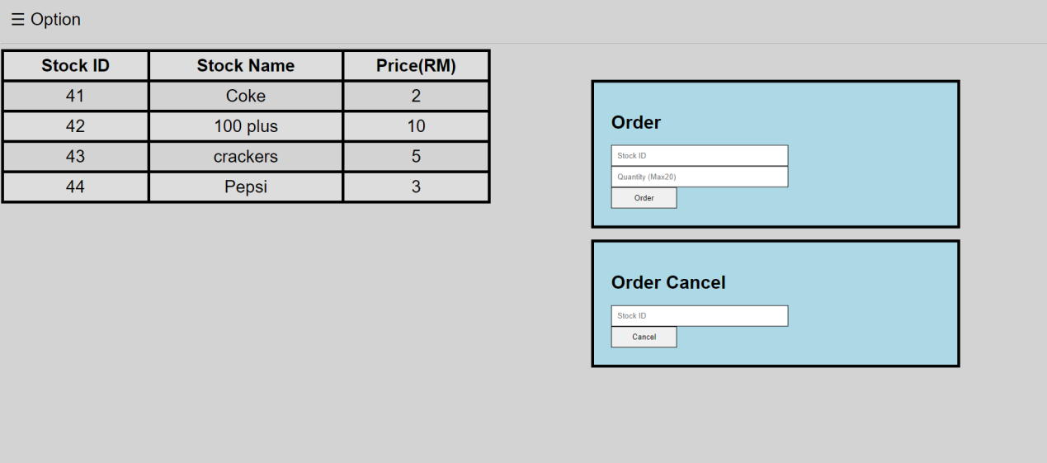

**Figure 5.13**

This is the user order page, user can check the list of Snacks & Drinks, right side got two boxes, user can key in the stock id and the quantity of the stock in the top box to place an order, if the user wish to cancel the wrong order or regret the order, user can check the payment page to get the order id and key into the bottom box to cancel the order.

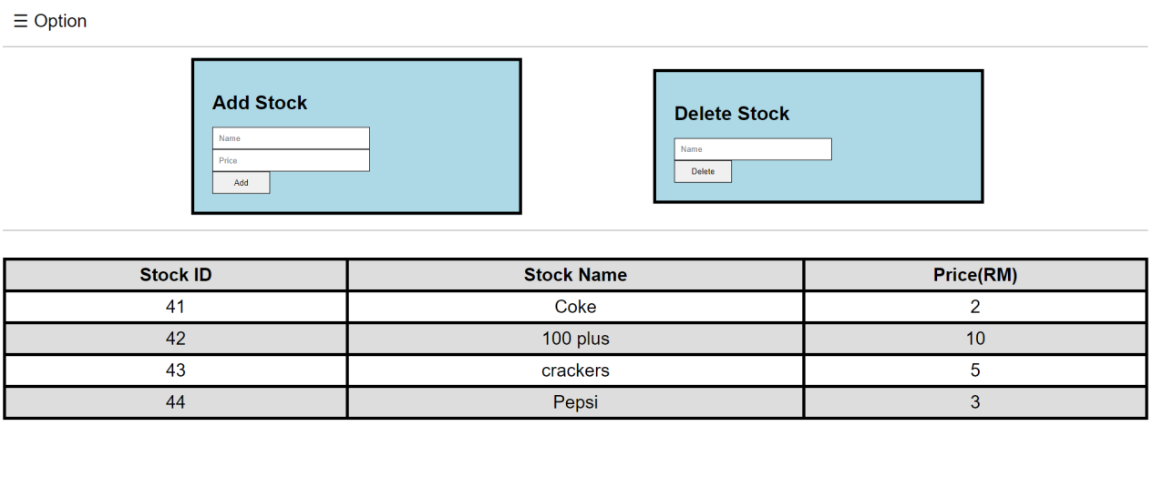

**Figure 5.14**

For admin, stock page allow them to modify the item selling, they can add a new item and give the price to it, so that the user can see when user access page in Figure 5.13. Admin can also delete the stock if the item is not available anymore.

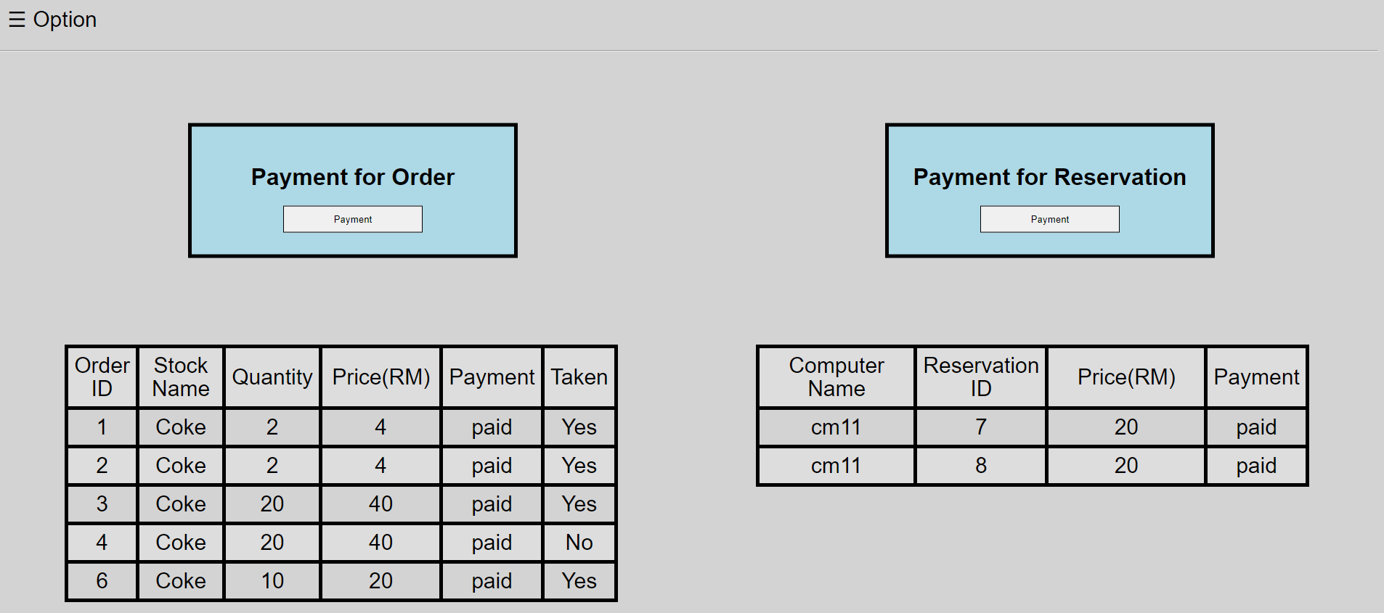

**Figure 5.15**

Figure 5.15 is the payment page for user, in this page user can check all the order and reservation, this page also provide the payment status for both payment. This status will be “unpaid” as default, when “unpaid” user can cancel the order or the reservation anytime. When the user finish the payment, the status will change into “paid”, when the order or reservation are paid, user can no longer cancel it.

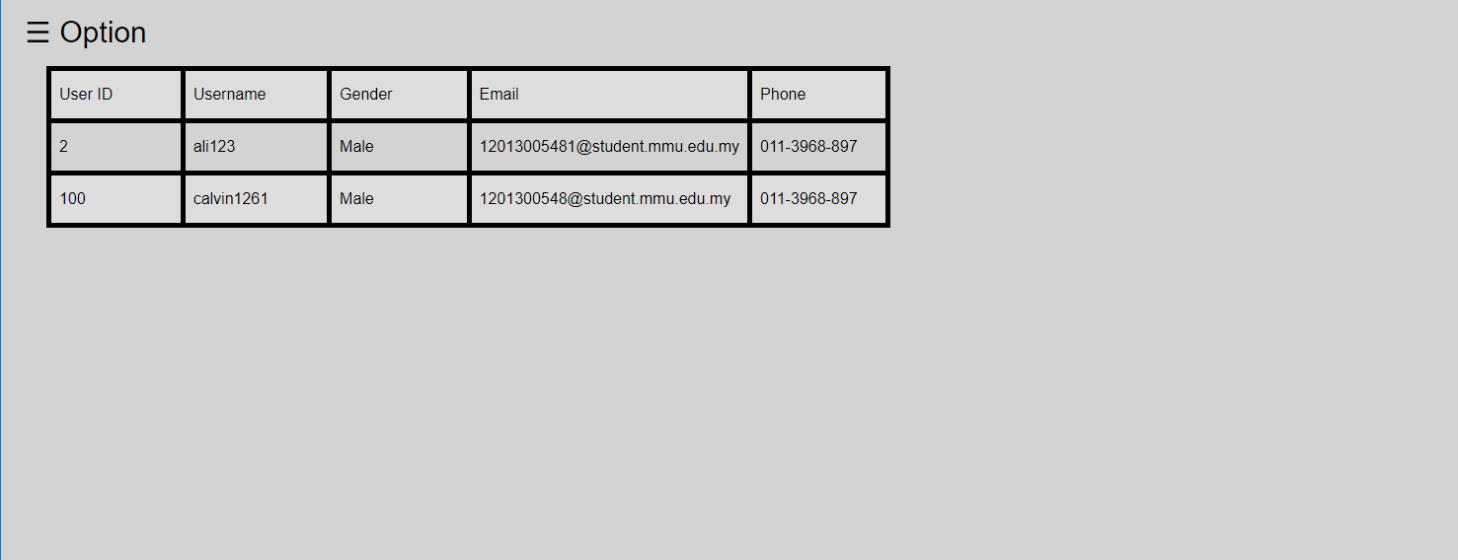

**Figure 5.16**

Admin can check all the user account from user list page. This page will list all the information of the user accept for the password.

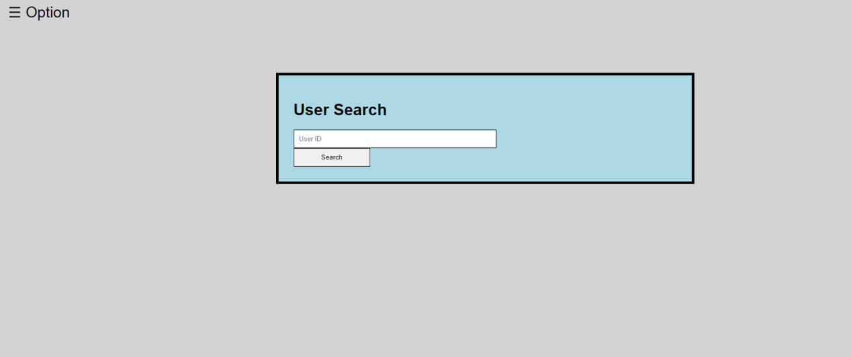

**Figure 5.17**

Figure 5.17 user search have some different compare with figure 5.16, admin can search a user based on the user id and check all the information and order in this account.

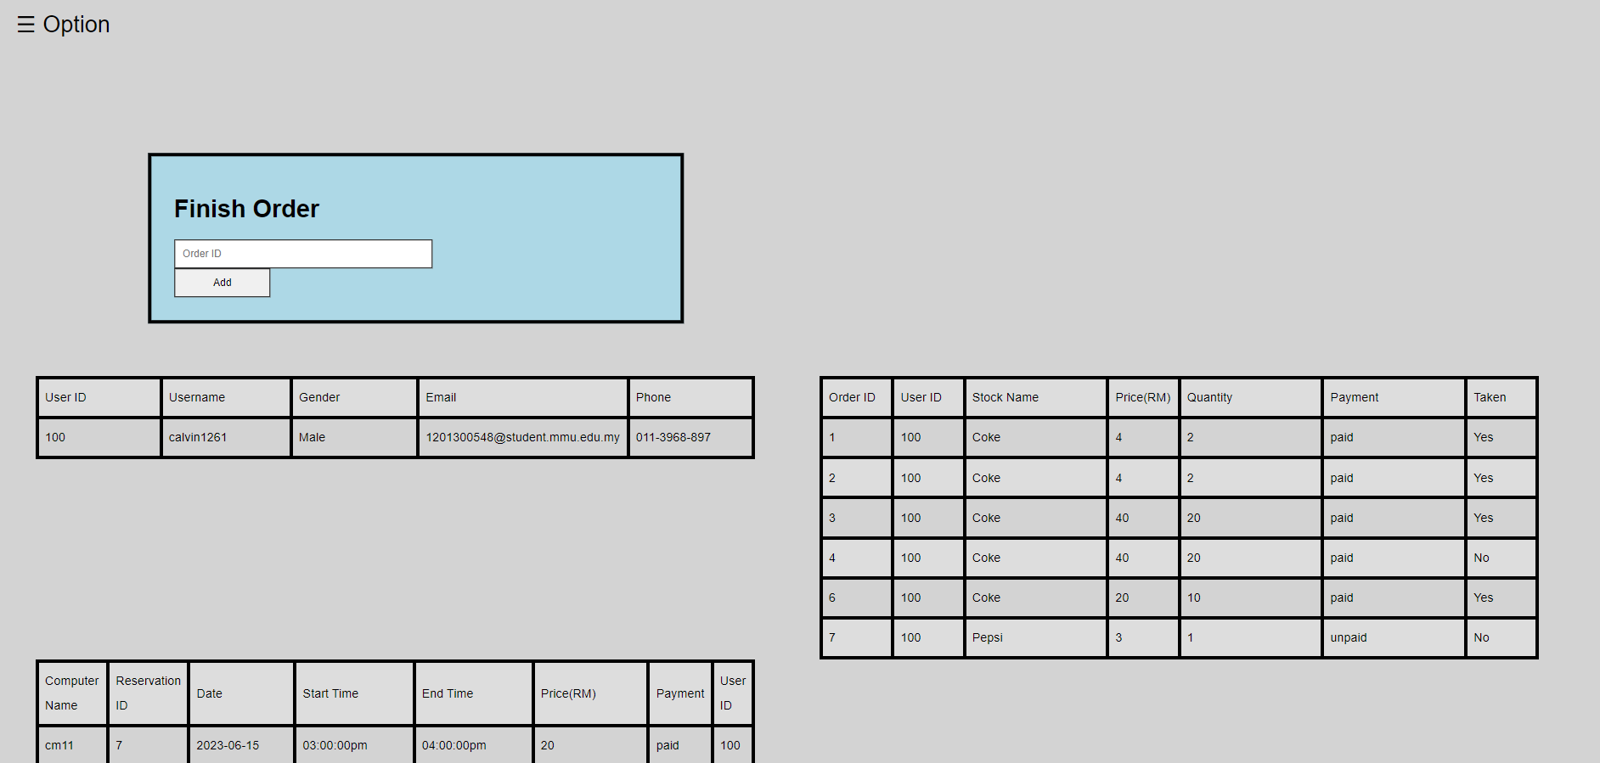

**Figure 5.18**

When search for a user based on the id given, it will show the information of the user account and also all the order and reservation done by this account. The finish order box is to settle the order that is paid by the user but still not taken the item they bought, admin can finish the order with order id when the user taken their item through the admin.

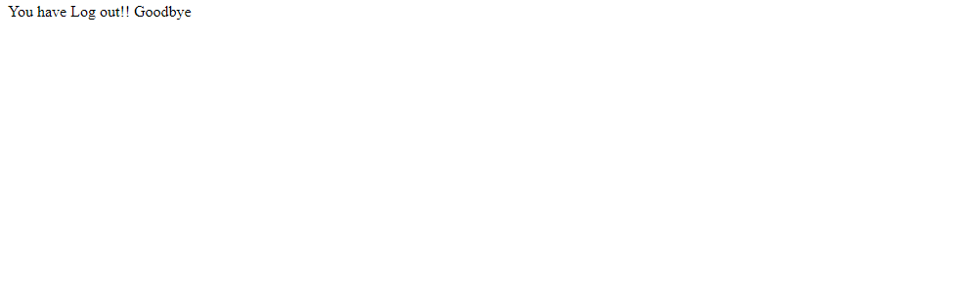

**Figure 5.19**

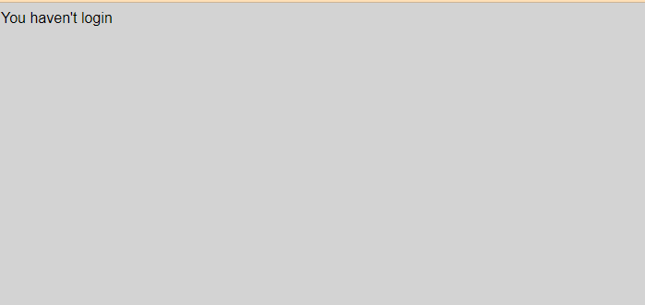

**Figure 5.20**

When the user or admin click on the logout button, their session will end, after logout all the pages that access after login as user will be no available anymore until they login again. The pages will show the user haven’t login.

**CHAPTER 6**

**TESTING**

Testing the function working of the system and also discuss and try about many possible that user may met in different situation when using this system. Either user or admin will have some miss clicked, misread, forget about the input they suppose to key in, so the system have some notification to tell them why they are entering the wrong input.

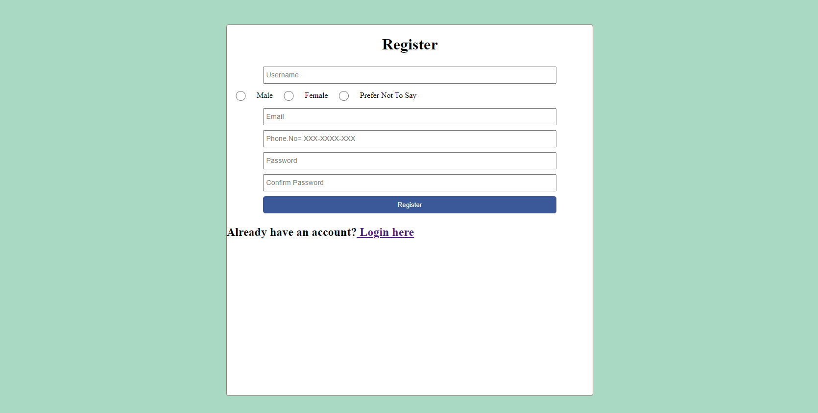

**Figure 6.1**

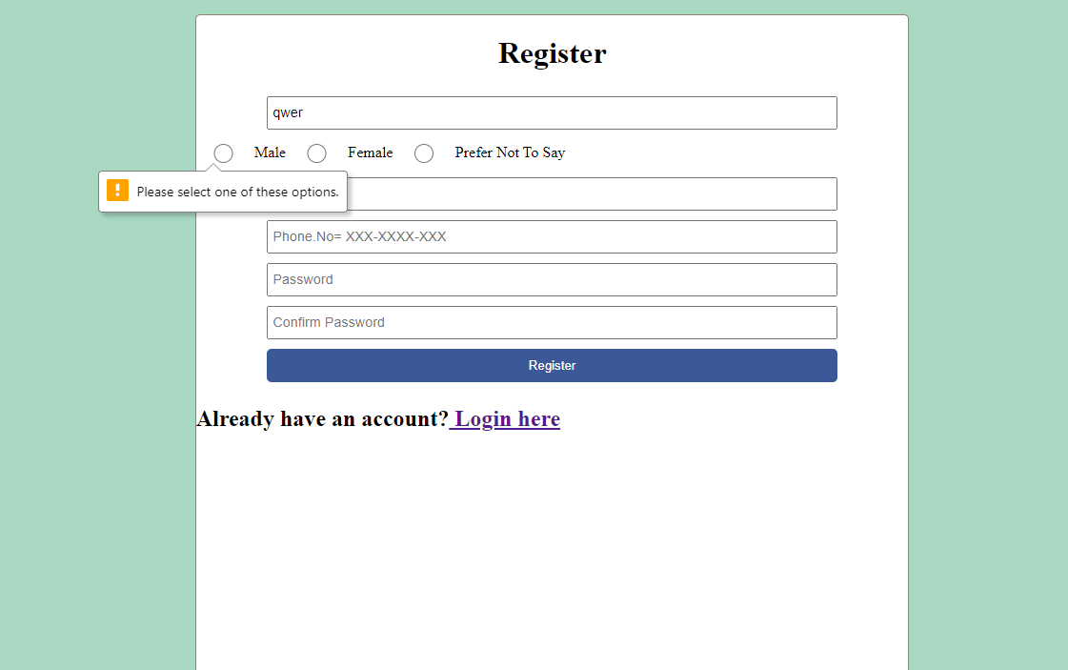

**Figure 6.2**

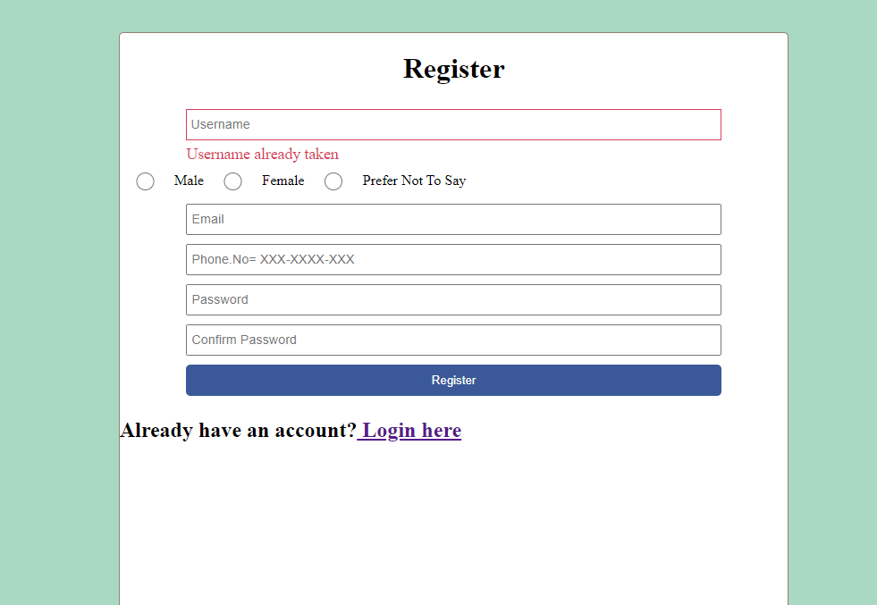

**Figure 6.3**

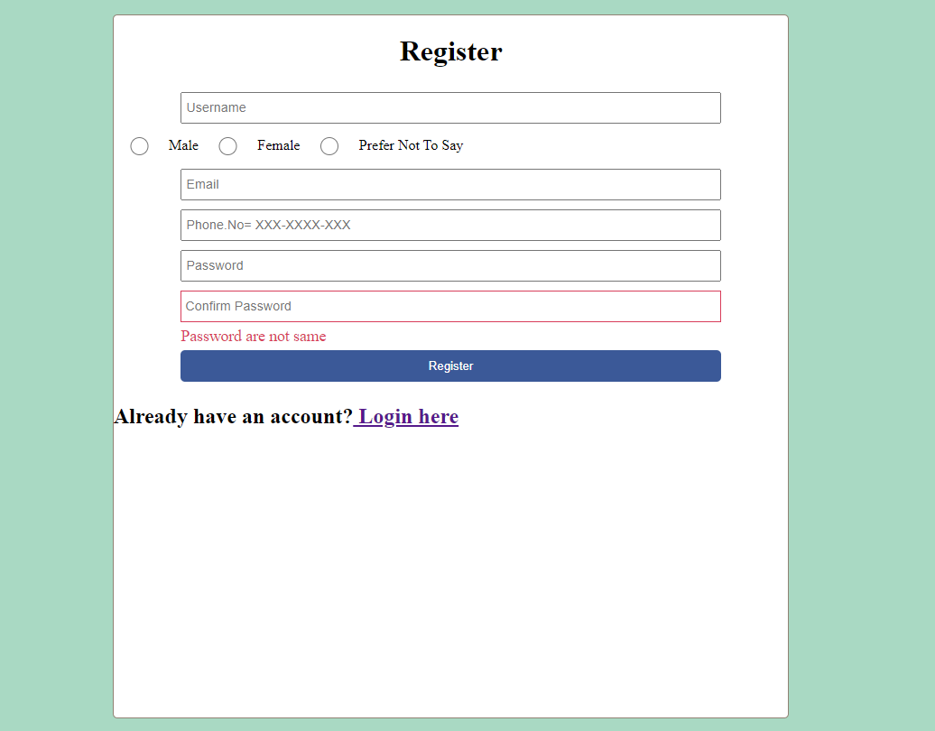

**Figure 6.4**



**Figure 6.5**

Figure 6.1, 6.2, 6.3 and 6.4 are the Register page, when user new to register page, the five information and one password confirm is require to register an account. Any of them is empty the system will notify the user need to key in related information.Figure 6.3 shows if the user enter the a name or a email that already exist in the database, which mean the username or the email already been used, the system will tell the new user to enter a different username or email to proceed the register. Figure 6.4 shows that if the user enter two different password the form will show incorrect password confirm. After register complete user will get the page show in Figure 6.5, they can proceed to login. All of these settings also works when come to admin part.

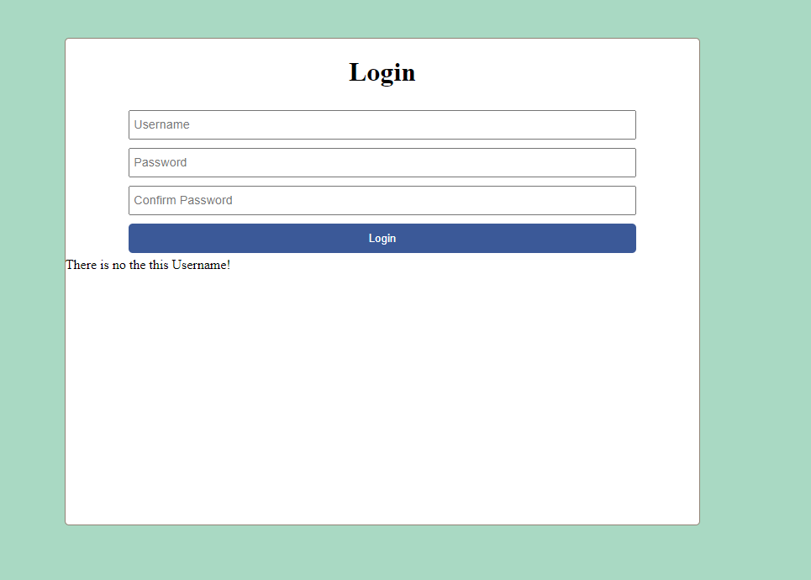

**Figure 6.6**

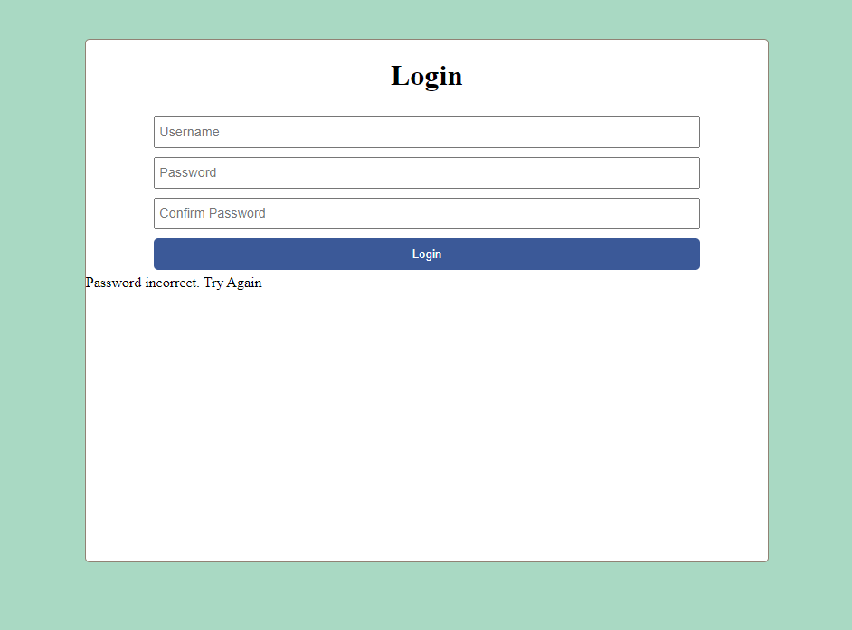

**Figure 6.7**

When user come to login page, they will need to enter their username with their password. When figure 6.6 is show, the username is not exist, mean that this username haven’t registered by anyone. If the username is exist, but the password is incorrect, the user will need to try again to enter the correct password. Also the confirm password works same as the register page. Admin login function also works same as user login.

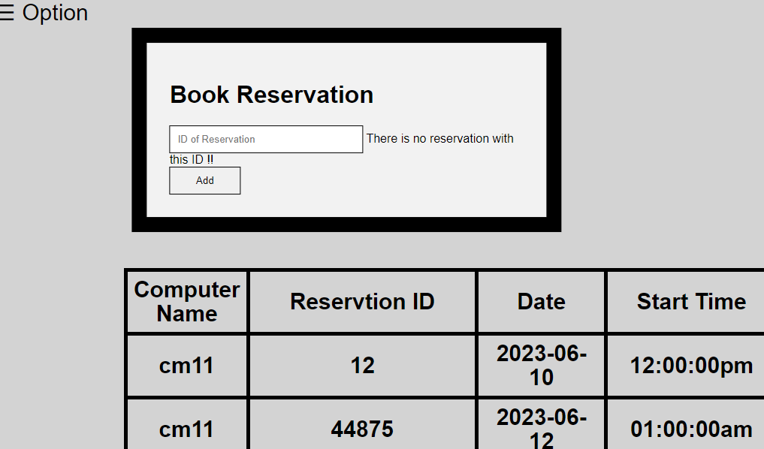

**Figure 6.8**

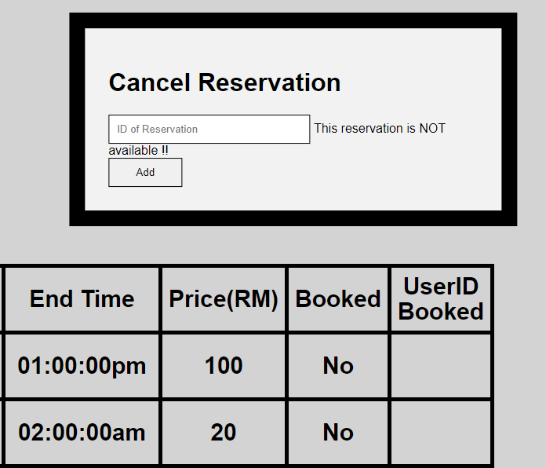

**Figure 6.9**

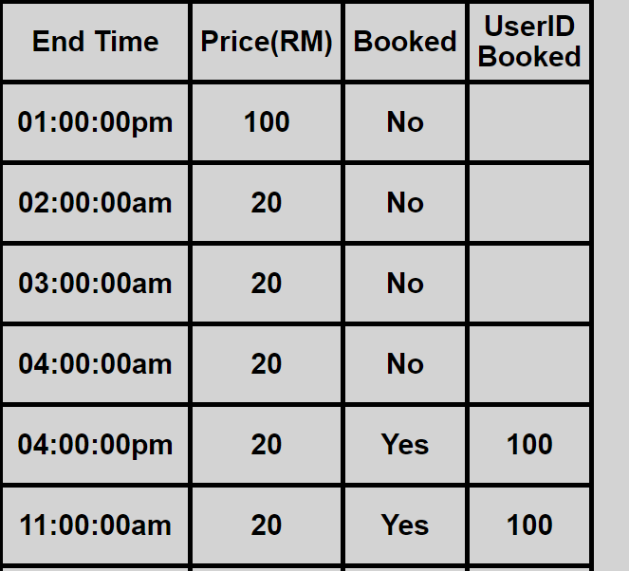

**Figure 6.10**

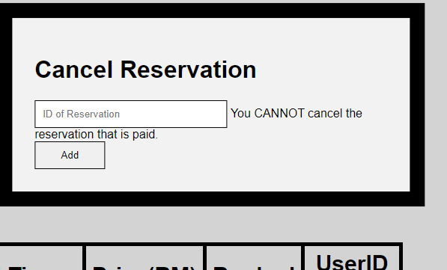

**Figure 6.11**

When user come to the reservation page,they can book for a reservation or cancel an unpaid reservation, if the reservation id is not exist the system will return error output for the user.Figure 6.10 is the list of reservation, when Booked slot shows Yes mean there is a user book for this reservation, and the User ID behind show behind is the one who book this slot. The User ID will be empty is the Booked status is No, user cancel the reservation also will change the Booked status to No and empty the User ID slot. User cannot cancel a reservation that is paid, figure 6.11 show the output when the user try to cancel a paid reservation.

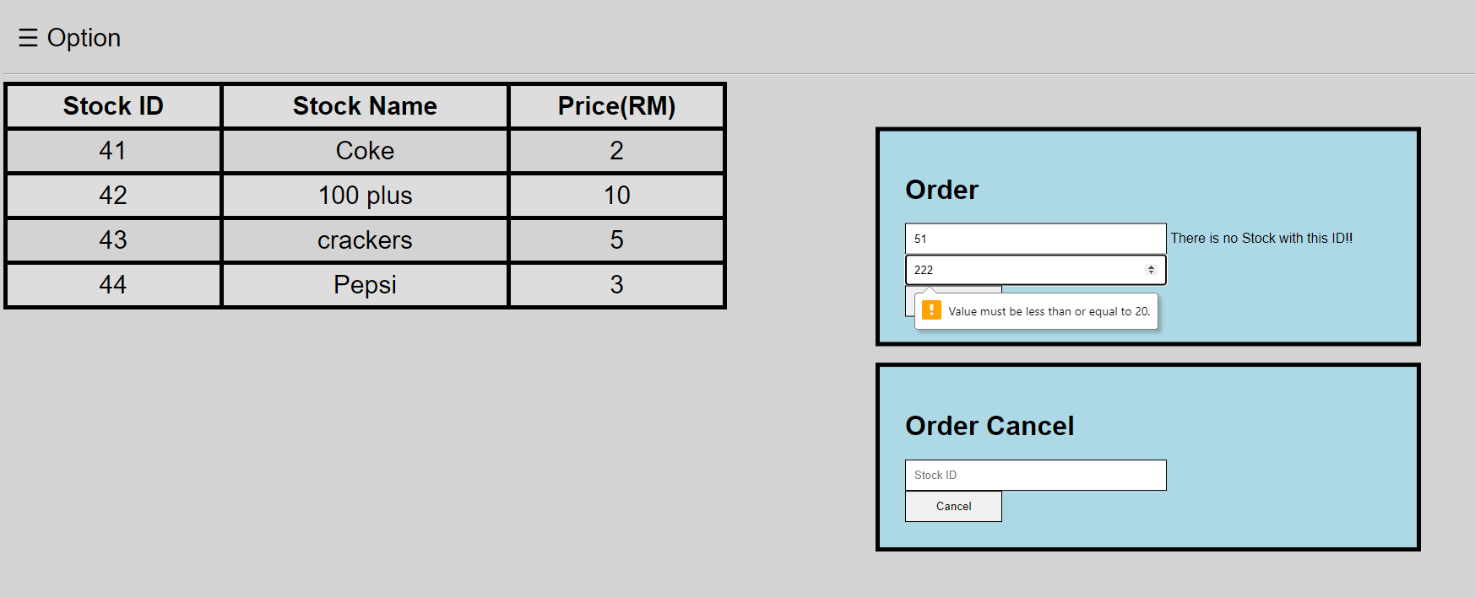

**Figure 6.12**

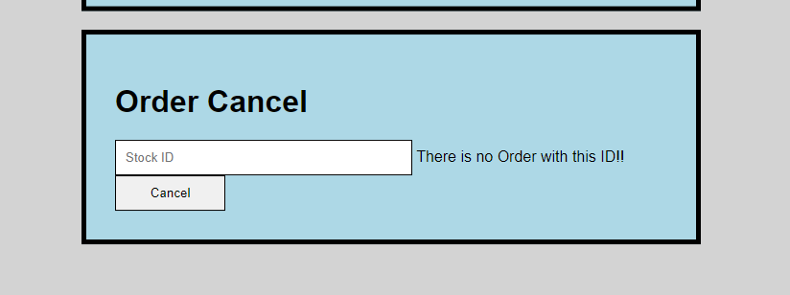

**Figure 6.13**

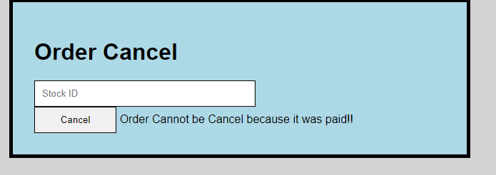

**Figure 6.14**

Order page allow user make an order based the stock available in the system, user enter stock id and the number they want. If the stock id is not exist error output will display, the quantity of the stock is set to be minimum 1 and maximum 20, so if user enter the number other than this range, they cannot place the order. Order cancel allow user to cancel the order they make but still haven’t paid, if the payment is finish then the user are not allow to cancel the order. If the order is not exist, there will be a error output show in figure 6.13 .The payment details of the order can be check in the payment page.

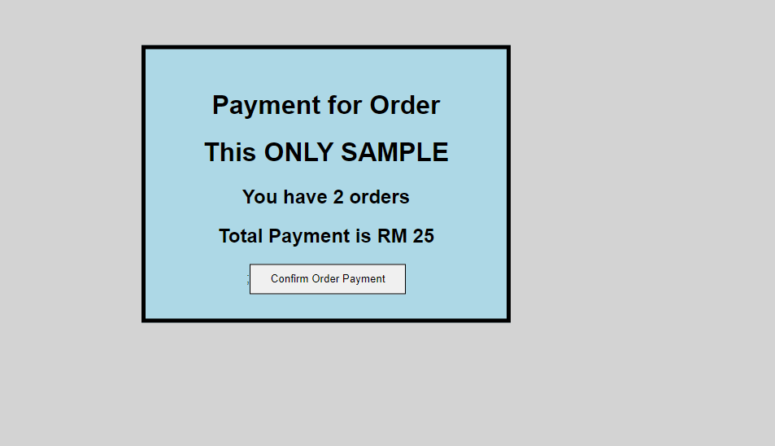

**Figure 6.15**

The payment for order and the reservation can be check and settle in the payment page. In this page will calculate all the order or payment price and show how many order and the total payment. The payment for the order and the reservation are separate. For the payment settle is only sample for now.

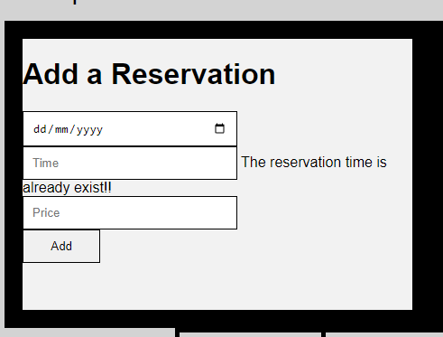

**Figure 6.16**

Reservation page for admin can modify reservation. Figure 6.16 allow admin add a reservation based on date, start time and price. If same date and time already have a reservation for the computer, the system will say the reservation is already exist.

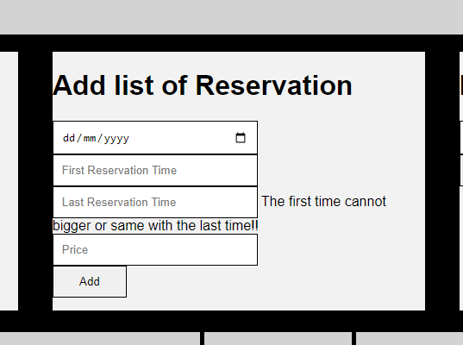

**Figure 6.17**

Another way to add reservation is the box show in figure 6.17. Add list of reservation allow admin to add many reservation in a date, first reservation time, last reservation time and price, The first reservation time cannot bigger than the last reservation time. The reservation will create start from the first time until the last time each hour one reservation.

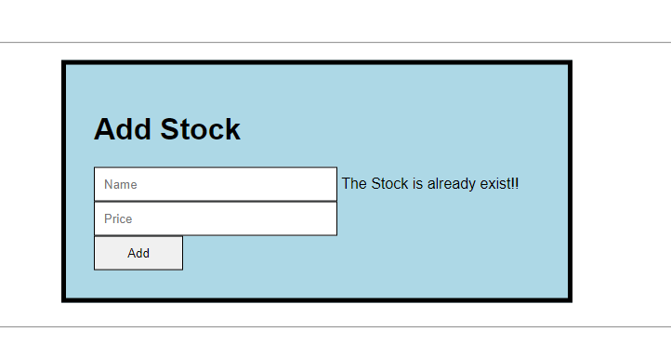

**Figure 6.17**

Admin can add new stock to the system with is add stock function, enter the name of the stock and the price for each of them the system will auto assign an unique id for the stock. If the name already exist, the input will not record and will show the stock is already exist.

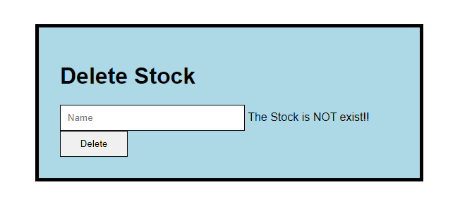

**Figure 6.18**

If the stock is not available anymore admin can enter the stock name to delete stock box. If the stock is not available, then the system will show the stock is NOT exist.

**CHAPTER 7**

**Conclusion**

Nowadays technology is very common and advanced, it help us in many way to improve our life quality and efficiency. One system can do many things we used to do manually on paper, it is difficult to manage a business in this age of information overload. A computer centre need to manage their devices, record all the information of the customer, need to tell every customer if any seat are not available, record and manage the snacks and drinks in the centre, etc. if they have no time to collect data or ask for feedback from the customer beside doing the manual record, how could the business improve. So they need a system to help them have a easier way to record and manage the centre.

The main outcome of this project is a computer centre reservation system. This system helps the computer centre to have a better management, also give the customer a way to find out the information of the centre. This system will improve the communication between the employee and the customer.

In FYP 1, the project have implement a scope which is provide a comfortable system for both customer and employee, in chapter 1, explained the intro of the system, what problem will met and their solution in this system. Project scope have a clearly target what this system can do and the gantt chart is the schedule for both FYP 1 and FYP 2. In literature review, this project learn and study three similar system, find out that most of the computer centre system have different feature beside the basic reservation function. This is a website based application, so the HTML will be the main development language, php, javascript, etc will be the support attached to HTML. The main user of this system are customers and employees, so the function will be focus on improve the comfortable of this two roles, also improve the communication between this two roles.

In FYP 2, this project will be start to development the system based on the documentation implement in FYP 1. FYP 2 will include 2 phases, the first phase will be develop the system, and the second phase will be testing and maintaining. The final outcome will be a complete computer centre reservation system.

**References**

(n.d.). About us. SENET. https://senet.cloud/en/about?utm_source=google&utm_medium=cpc&utm_campaign=Search_EN_India_Brand&utm_adgroup=ENG_Senet_Exact&utm_term=ENG_Senet_Exact&utm_content=senet&gclid=Cj0KCQiA5NSdBhDfARIsALzs2EDGFoLcniv0o2e_RcSgR4Y46T5mv2GihP4RfhwrUW08J-takQNpfD0aAlBmEALw_wcB

George, J. F., & Valacich, J. S. (2017). Modern systems analysis and design (8th ed.). Pearson Education Limited, Harlow, Essex, 2017.

1. B. (n.d.). Web development. Global Media Insight. <https://www.globalmediainsight.com/blog/programming-languages-web-development/>

(n.d.). SDLC. Synopsys. <https://www.synopsys.com/glossary/what-is-sdlc.html#:~:text=The%20Software%20Development%20Life%20Cycle%20(SDLC)%20is%20a%20structured%20process,all%20customer%20expectations%20and%20demands.>

(n.d.). HTML. Educba. https://www.educba.com/uses-of-html/

<https://www.codecademy.com/resources/blog/what-is-html/>

HTML. (2022, December 29). In Wikipedia. <https://en.wikipedia.org/wiki/HTML>

(G. B. (n.d.). Web development. Global Media Insight.) <https://www.globalmediainsight.com/blog/programming-languages-web-development/#html>

CSS. (2022, December 23). In Wikipedia. <https://en.wikipedia.org/wiki/CSS>

Style sheet language. (2022, August 11). In Wikipedia. <https://en.wikipedia.org/wiki/Style_sheet_language>

PHP. (2022, December 30). In Wikipedia. https://en.wikipedia.org/wiki/PHP

Appendix A: FYP Meeting Log

Faculty of Information Science and Technology (FIST)

## Final Year Project Meeting Log

(To be filled in by Student)

|  |  |
| --- | --- |
| **MEETING DATE: 03/04/2023** | **MEETING NO.: 1** |
| **PROJECT ID: T801932** |  |
| **PROJECT TITLE : COMPUTER CENTRE RESERVATION SYSTEM** | |
| **SESSION : 2022/2023** | **SUPERVISOR : Dr. Khoh Wee How** |
| **STUDENTID &Name:1201300548 Cheong Ji Xiang** | **CO- SUPERVISOR :** |

|  |
| --- |
| 1. **WORK DONE** |
| 1. **WORK TO BE DONE**   Start to develop the system |
| 1. **PROBLEMS ENCOUNTERED** |
| **4. COMMENTS** |



|  |  |  |  |  |
| --- | --- | --- | --- | --- |
| Supervisor’s Signature &  Stamp |  | Co-Supervisor’s Signature  & Stamp (if any) |  | Student’s Signature |

NOTES:

1. Items 1 – 3 are to be completed by the students before coming for the meeting. Item 4 is to be completed by the supervisor.
2. For FYP Phase 1, total six log sheets are to be submitted (every other week*).
3. For FYP Phase 2, total six log sheets are to be submitted (every other week**).
4. Log sheets are compulsory assessment criteria for FYP. Student who fails to meet the requirements of log sheets will not be allowed to submit FYP report.

*: week 1, 3, 5, 7, 9, 11 or 2, 4, 6, 8, 10, 11 of the first trimester (week 12: report submission, weeks

13 & 14: presentation)

**: week 1, 3, 5, 7, 9, 11 or 2, 4, 6, 8, 10, 11 of the second trimester (week 12: report submission,

weeks 13 & 14: presentation)

Appendix A: FYP Meeting Log

Faculty of Information Science and Technology (FIST)

## Final Year Project Meeting Log

(To be filled in by Student)

|  |  |
| --- | --- |
| **MEETING DATE:10/04/2023** | **MEETING NO.:2** |
| **PROJECT ID:T801932** |  |
| **PROJECT TITLE :COMPUTER CENTRE RESERVATION SYSTEM** | |
| **SESSION :2022/2023** | **SUPERVISOR :Dr. Khoh Wee How** |
| **STUDENTID &Name:1201300548 Cheong Ji Xiang** | **CO- SUPERVISOR :** |

|  |
| --- |
| 1. **WORK DONE** |
| 1. **WORK TO BE DONE**   **Continue to develop the program** |
| 1. **PROBLEMS ENCOUNTERED** |
| **4. COMMENTS** |

|  |  |  |  |  |
| --- | --- | --- | --- | --- |
| Supervisor’s Signature &  Stamp |  | Co-Supervisor’s Signature  & Stamp (if any) |  | Student’s Signature |



NOTES:

1. Items 1 – 3 are to be completed by the students before coming for the meeting. Item 4 is to be completed by the supervisor.
2. For FYP Phase 1, total six log sheets are to be submitted (every other week*).
3. For FYP Phase 2, total six log sheets are to be submitted (every other week**).
4. Log sheets are compulsory assessment criteria for FYP. Student who fails to meet the requirements of log sheets will not be allowed to submit FYP report.

*: week 1, 3, 5, 7, 9, 11 or 2, 4, 6, 8, 10, 11 of the first trimester (week 12: report submission, weeks

13 & 14: presentation)

**: week 1, 3, 5, 7, 9, 11 or 2, 4, 6, 8, 10, 11 of the second trimester (week 12: report submission,

weeks 13 & 14: presentation)

Appendix A: FYP Meeting Log

Faculty of Information Science and Technology (FIST)

## Final Year Project Meeting Log

(To be filled in by Student)

|  |  |
| --- | --- |
| **MEETING DATE:01/05/2023** | **MEETING NO.:3** |
| **PROJECT ID:T801932** |  |
| **PROJECT TITLE :COMPUTER CENTRE RESERVATION SYSTEM** | |
| **SESSION :2022/2023** | **SUPERVISOR :Dr. Khoh Wee How** |
| **STUDENTID &Name:1201300548 Cheong Ji Xiang** | **CO- SUPERVISOR :** |

|  |
| --- |
| 1. **WORK DONE**   Finish the coding |
| 1. **WORK TO BE DONE**   Testing System and debug |
| 1. **PROBLEMS ENCOUNTERED** |
| **4. COMMENTS** |

|  |  |  |  |  |
| --- | --- | --- | --- | --- |
| Supervisor’s Signature &  Stamp |  | Co-Supervisor’s Signature  & Stamp (if any) |  | Student’s Signature |



NOTES:

1. Items 1 – 3 are to be completed by the students before coming for the meeting. Item 4 is to be completed by the supervisor.
2. For FYP Phase 1, total six log sheets are to be submitted (every other week*).
3. For FYP Phase 2, total six log sheets are to be submitted (every other week**).
4. Log sheets are compulsory assessment criteria for FYP. Student who fails to meet the requirements of log sheets will not be allowed to submit FYP report.

*: week 1, 3, 5, 7, 9, 11 or 2, 4, 6, 8, 10, 11 of the first trimester (week 12: report submission, weeks

13 & 14: presentation)

**: week 1, 3, 5, 7, 9, 11 or 2, 4, 6, 8, 10, 11 of the second trimester (week 12: report submission,

weeks 13 & 14: presentation)

Appendix A: FYP Meeting Log

Faculty of Information Science and Technology (FIST)

## Final Year Project Meeting Log

(To be filled in by Student)

|  |  |
| --- | --- |
| **MEETING DATE:30/05/2023** | **MEETING NO.:4** |
| **PROJECT ID:T801932** |  |
| **PROJECT TITLE :COMPUTER CENTRE RESERVATION SYSTEM** | |
| **SESSION :2022/2023** | **SUPERVISOR :Dr. Khoh Wee How** |
| **STUDENTID &Name:1201300548 Cheong Ji Xiang** | **CO- SUPERVISOR :** |

|  |
| --- |
| 1. **WORK DONE**   Testing the code for any possible combination and debug |
| 1. **WORK TO BE DONE**   Finalize the code and compile the file |
| 1. **PROBLEMS ENCOUNTERED** |
| **4. COMMENTS** |



|  |  |  |  |  |
| --- | --- | --- | --- | --- |
| Supervisor’s Signature &  Stamp |  | Co-Supervisor’s Signature  & Stamp (if any) |  | Student’s Signature |

NOTES:

1. Items 1 – 3 are to be completed by the students before coming for the meeting. Item 4 is to be completed by the supervisor.
2. For FYP Phase 1, total six log sheets are to be submitted (every other week*).
3. For FYP Phase 2, total six log sheets are to be submitted (every other week**).
4. Log sheets are compulsory assessment criteria for FYP. Student who fails to meet the requirements of log sheets will not be allowed to submit FYP report.

*: week 1, 3, 5, 7, 9, 11 or 2, 4, 6, 8, 10, 11 of the first trimester (week 12: report submission, weeks

13 & 14: presentation)

**: week 1, 3, 5, 7, 9, 11 or 2, 4, 6, 8, 10, 11 of the second trimester (week 12: report submission,

weeks 13 & 14: presentation)

Appendix A: FYP Meeting Log

Faculty of Information Science and Technology (FIST)

## Final Year Project Meeting Log

(To be filled in by Student)

|  |  |
| --- | --- |
| **MEETING DATE:02/06/2023** | **MEETING NO.:5** |
| **PROJECT ID:T801932** |  |
| **PROJECT TITLE :COMPUTER CENTRE RESERVATION SYSTEM** | |
| **SESSION :2022/2023** | **SUPERVISOR :Dr. Khoh Wee How** |
| **STUDENTID &Name:1201300548 Cheong Ji Xiang** | **CO- SUPERVISOR :** |

|  |
| --- |
| 1. **WORK DONE**   Finalize the code and compile the file |
| 1. **WORK TO BE DONE**   **Check FYP 1 and modify** |
| **3. PROBLEMS ENCOUNTERED** |
| **4. COMMENTS** |



|  |  |  |  |  |
| --- | --- | --- | --- | --- |
| Supervisor’s Signature &  Stamp |  | Co-Supervisor’s Signature  & Stamp (if any) |  | Student’s Signature |



NOTES:

1. Items 1 – 3 are to be completed by the students before coming for the meeting. Item 4 is to be completed by the supervisor.
2. For FYP Phase 1, total six log sheets are to be submitted (every other week*).
3. For FYP Phase 2, total six log sheets are to be submitted (every other week**).
4. Log sheets are compulsory assessment criteria for FYP. Student who fails to meet the requirements of log sheets will not be allowed to submit FYP report.

*: week 1, 3, 5, 7, 9, 11 or 2, 4, 6, 8, 10, 11 of the first trimester (week 12: report submission, weeks

13 & 14: presentation)

**: week 1, 3, 5, 7, 9, 11 or 2, 4, 6, 8, 10, 11 of the second trimester (week 12: report submission,

weeks 13 & 14: presentation)

Appendix A: FYP Meeting Log

Faculty of Information Science and Technology (FIST)

## Final Year Project Meeting Log

(To be filled in by Student)

|  |  |
| --- | --- |
| **MEETING DATE:07/06/2023** | **MEETING NO.:6** |
| **PROJECT ID:T801932** |  |
| **PROJECT TITLE :COMPUTER CENTRE RESERVATION SYSTEM** | |
| **SESSION :2022/2023** | **SUPERVISOR :Dr. Khoh Wee How** |
| **STUDENTID &Name:1201300548 Cheong Ji Xiang** | **CO- SUPERVISOR :** |

|  |
| --- |
| 1. **WORK DONE**   **Check FYP 1 and modify** |
| 1. **WORK TO BE DONE**   Finalize the FYP 2 Report |
| **3. PROBLEMS ENCOUNTERED** |
| **4. COMMENTS** |



|  |  |  |  |  |
| --- | --- | --- | --- | --- |
| Supervisor’s Signature &  Stamp |  | Co-Supervisor’s Signature  & Stamp (if any) |  | Student’s Signature |

NOTES:

1. Items 1 – 3 are to be completed by the students before coming for the meeting. Item 4 is to be completed by the supervisor.
2. For FYP Phase 1, total six log sheets are to be submitted (every other week*).
3. For FYP Phase 2, total six log sheets are to be submitted (every other week**).
4. Log sheets are compulsory assessment criteria for FYP. Student who fails to meet the requirements of log sheets will not be allowed to submit FYP report.

*: week 1, 3, 5, 7, 9, 11 or 2, 4, 6, 8, 10, 11 of the first trimester (week 12: report submission, weeks

13 & 14: presentation)

**: week 1, 3, 5, 7, 9, 11 or 2, 4, 6, 8, 10, 11 of the second trimester (week 12: report submission,

weeks 13 & 14: presentation)

Appendix A: FYP Meeting Log

Library Literacy Course (LLC) Meeting Log

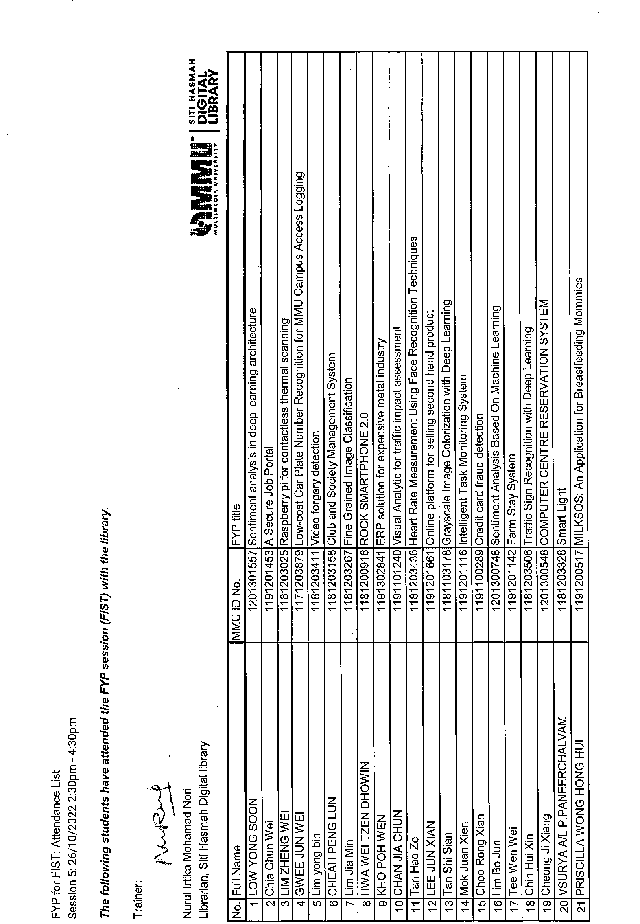

Appendix B: Checklist for FYP Interim Submission



Faculty of Information Science and Technology (FIST)

**Checklist for Interim Report Submission**

**(To be filled in by Student)**

**STUDENT’S DETAILS**

|  |  |
| --- | --- |
| Project Code | **FIST** |
| Name | Cheong Ji Xiang |
| ID No | 1201300548 |
| Title of Thesis | COMPUTER CENTRE RESERVATION SYSTEM |
| Supervisor Name | Dr. Khoh Wee How |

|  |  |  |
| --- | --- | --- |
| **REPORT ARRANGEMENT** | **√** | **Comments (if any differences)** |
| 1. Cover of The Interim Report | **√** |  |
| 2. Title Page of the Interim Report | **√** |  |
| 3 Copyright page of I Interim Report | **√** |  |
| 4. Declaration Page of Interim report | **√** |  |
| 5. Acknowledgement | **√** |  |
| 6. Table of Contents | **√** |  |
| 7. Abstract | **√** |  |
| 8. List of Tables | **√** |  |
| 9. List of Figures | **√** |  |
| 10. List of Symbols | **√** |  |
| 11. List of Appendices | **√** |  |
| 12. Chapter 1: Introduction – objectives, scope | **√** |  |
| 13. Chapter 2: Literature Review | **√** |  |
| 14. Chapter 3: Methodology | **√** |  |
| 15. Chapter 4: System Design | **√** |  |
| 16. Chapter 5: System Implementation | **√** |  |
| 17. Chapter 6: System Testing | **√** |  |
| 16. Chapter 7: Conclusion | **√** |  |
| 17. References – APA style | **√** |  |
| 18. Appendices | **√** |  |
| 19. CD/ DVD and envelope as shown in Appendix K | - |  |
| 20. Attachment : FYP Meeting Logs (all) 1 set | **√** |  |

|  |  |  |
| --- | --- | --- |
| **FORMAT OF REPORT** | **√** | **Comments** |
| 1. Page Numbering | **√** |  |
| 2. Font and Type Face | **√** |  |
| 3. Font Cover | **√** |  |
| 4. Tables and Figures | **√** |  |
| 5. Comb Bind | - |  |
| 6. Colour of the Front Cover | - |  |
| 7. Number of words > 10000(Main content only) | **√** |  |

Checked by



Student’s Signature & Date